**Task 1**

Checking the IP address of all Machines.

IP Address of Machine 1: **10.0.2.7**, Machine 2: **10.0.2.8**, and Machine 3: **10.0.2.9**

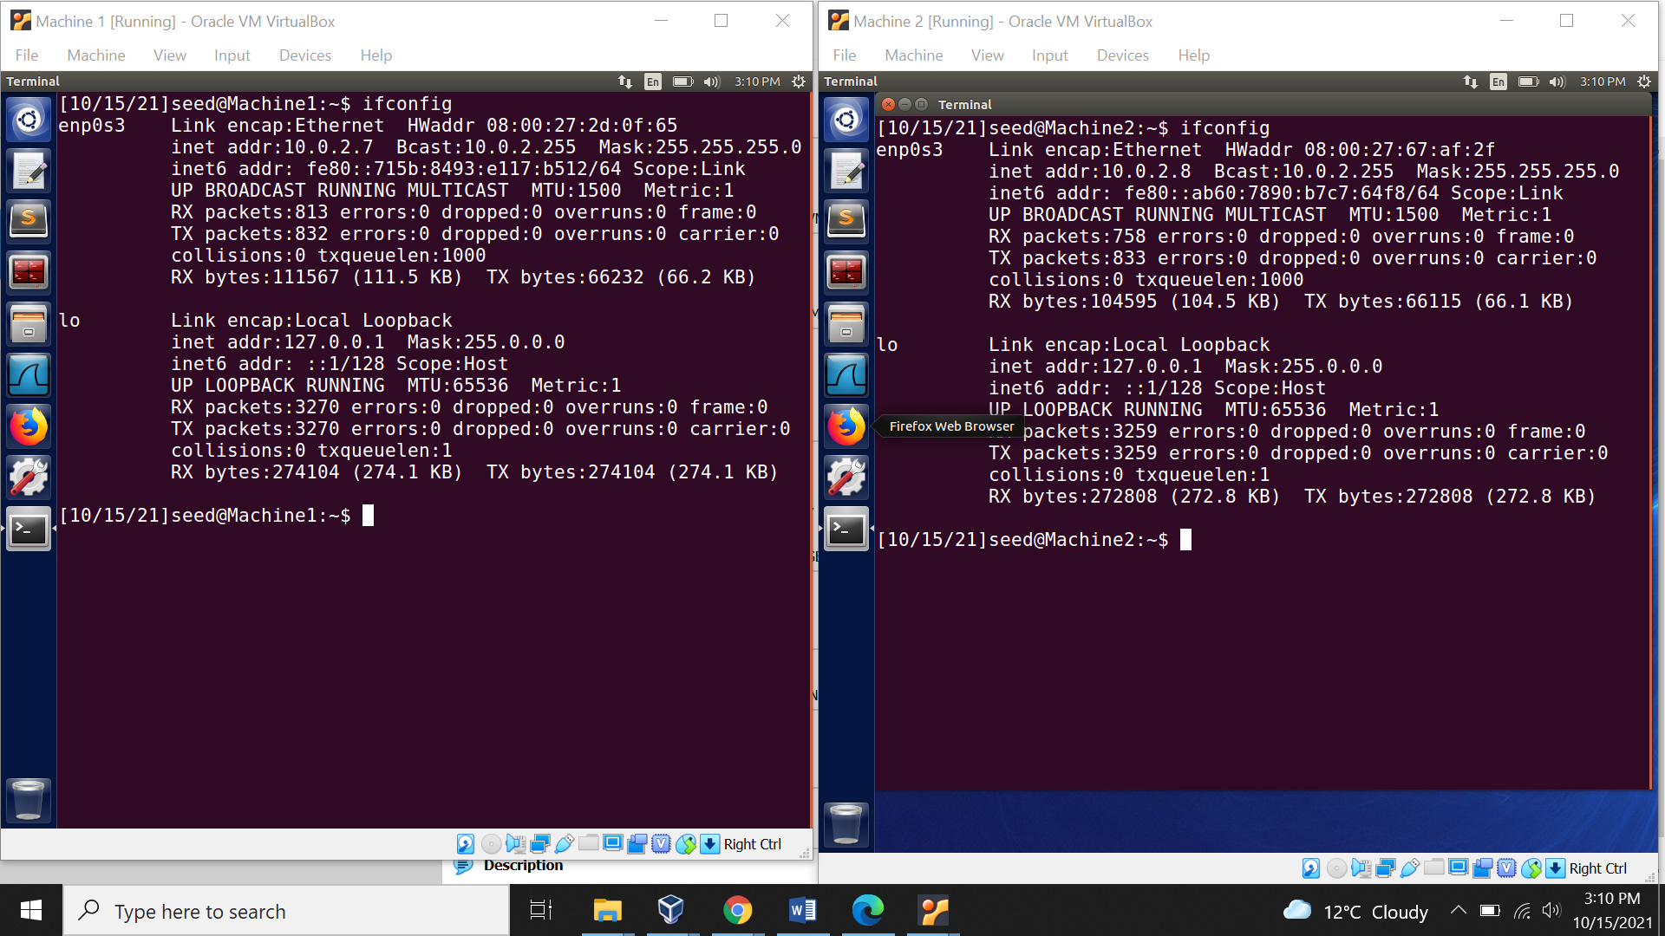

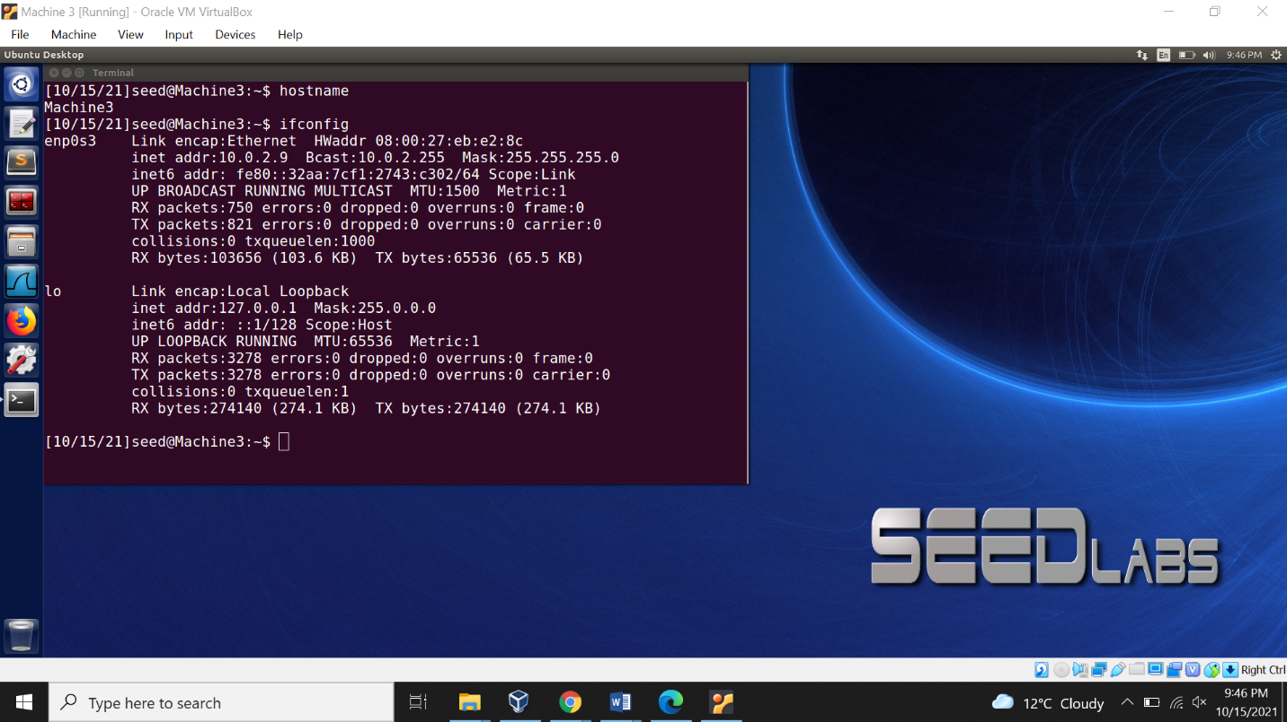

Task 1: Using Firewall

1. Prevent Machine 1 from doing telnet to Machine 2

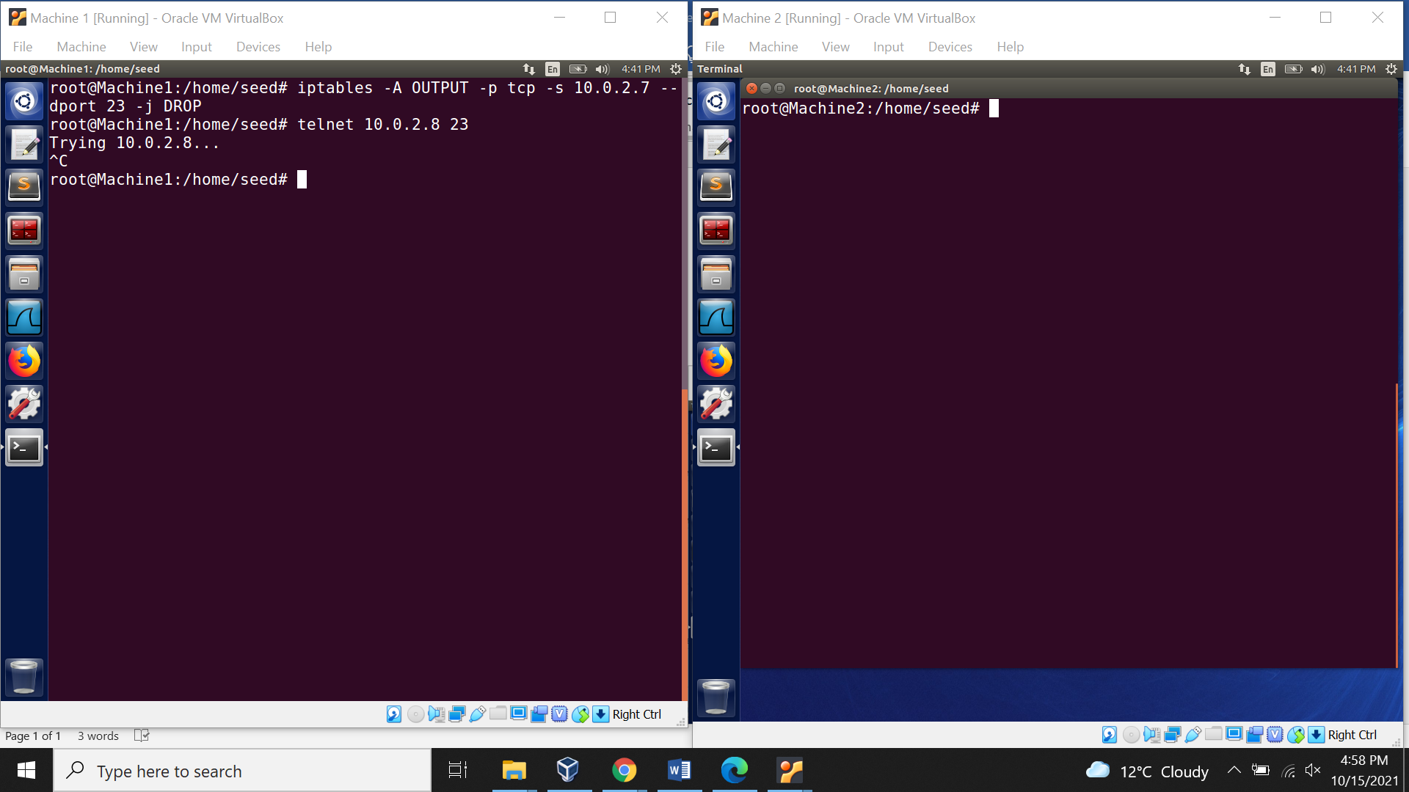

1. Prevent Telnet from Machine 2 to Machine 1

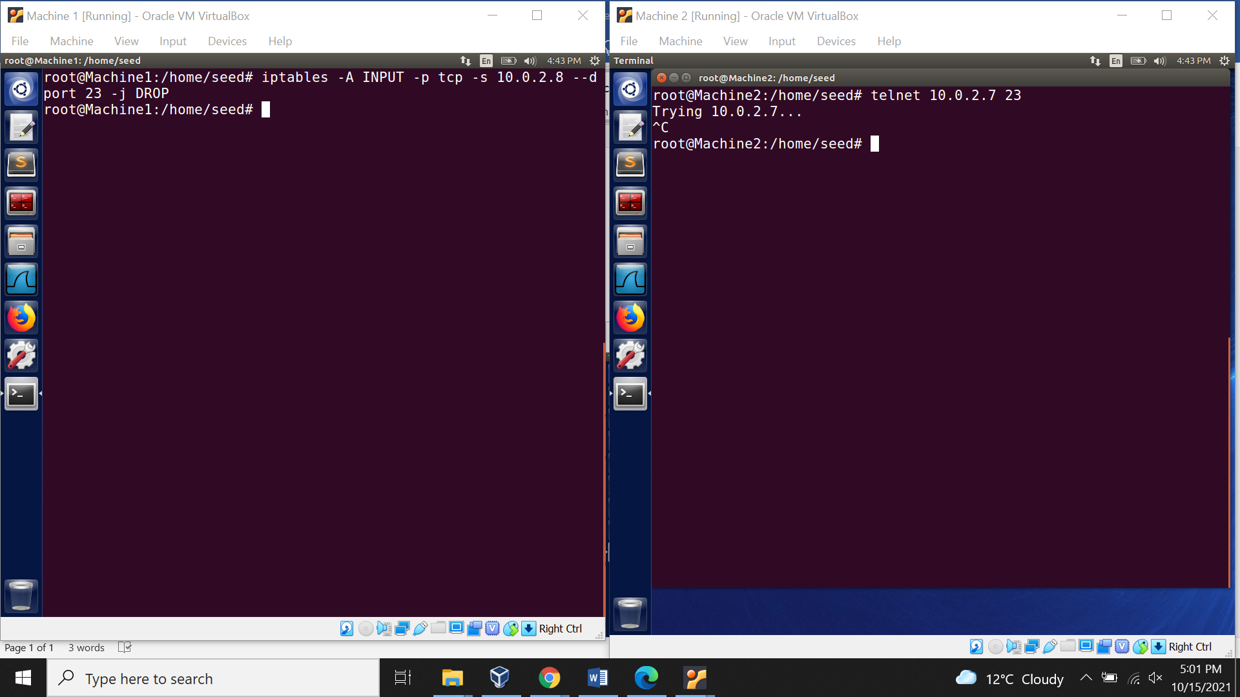

1. Prevent Machine 1 from visiting an external website.

Finding the IP address oof the external website ‘www.bhavans.ac.in”. Secondly, blocking the Machine 1 access to the external website [www.bhavans.ac.in](http://www.bhavans.ac.in) using the iptables.

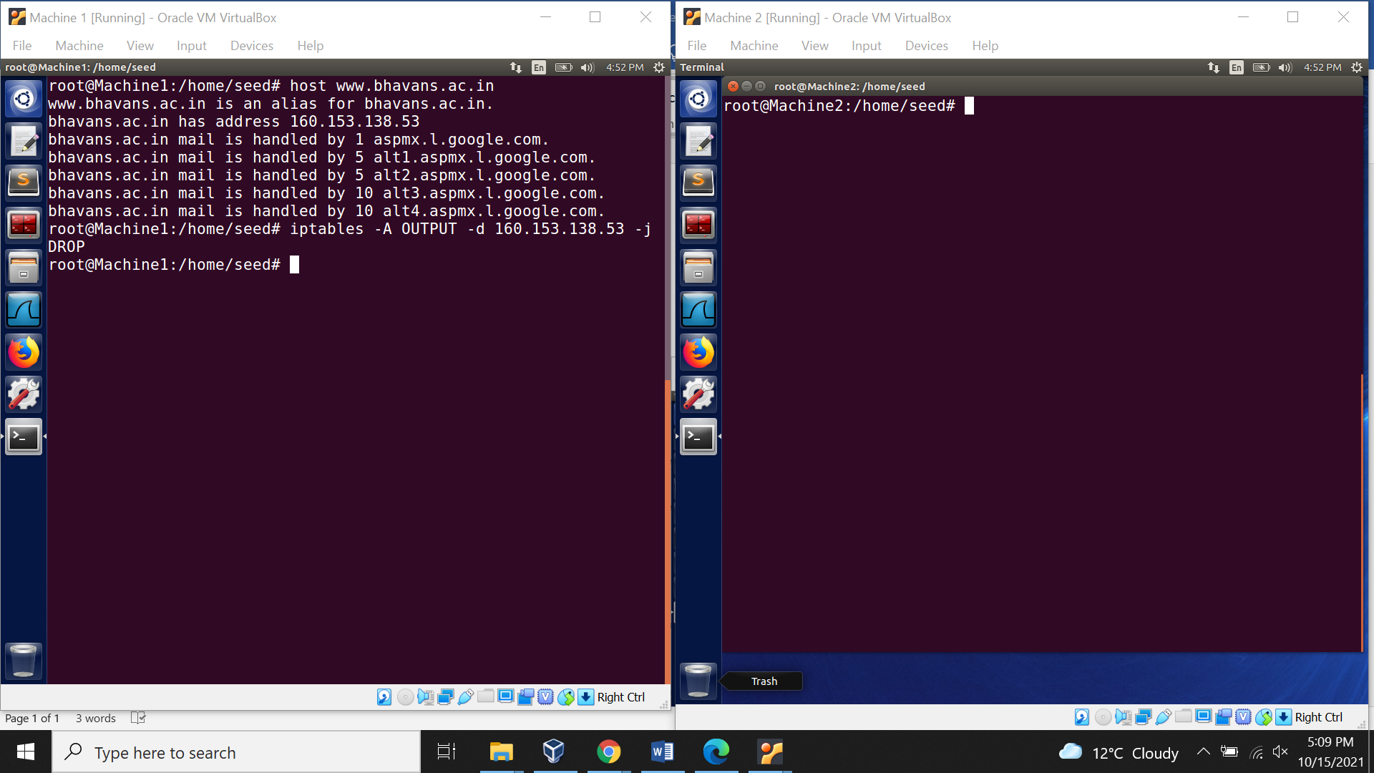

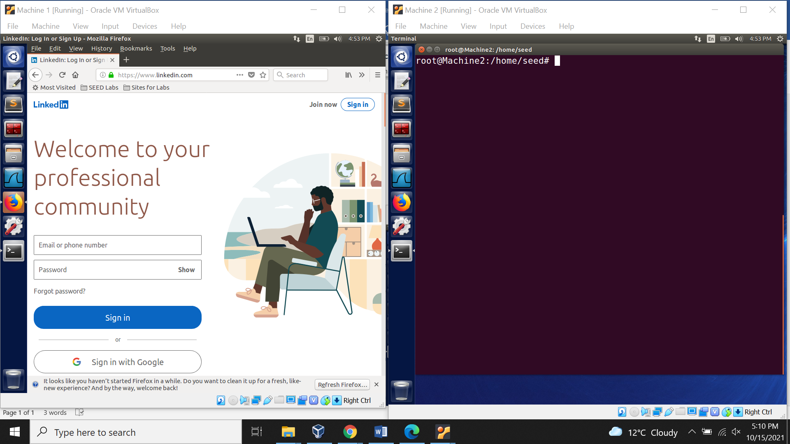

External webpage cannot be accessed as [www.bhavans.ac.in](http://www.bhavans.ac.in) is already blocked.

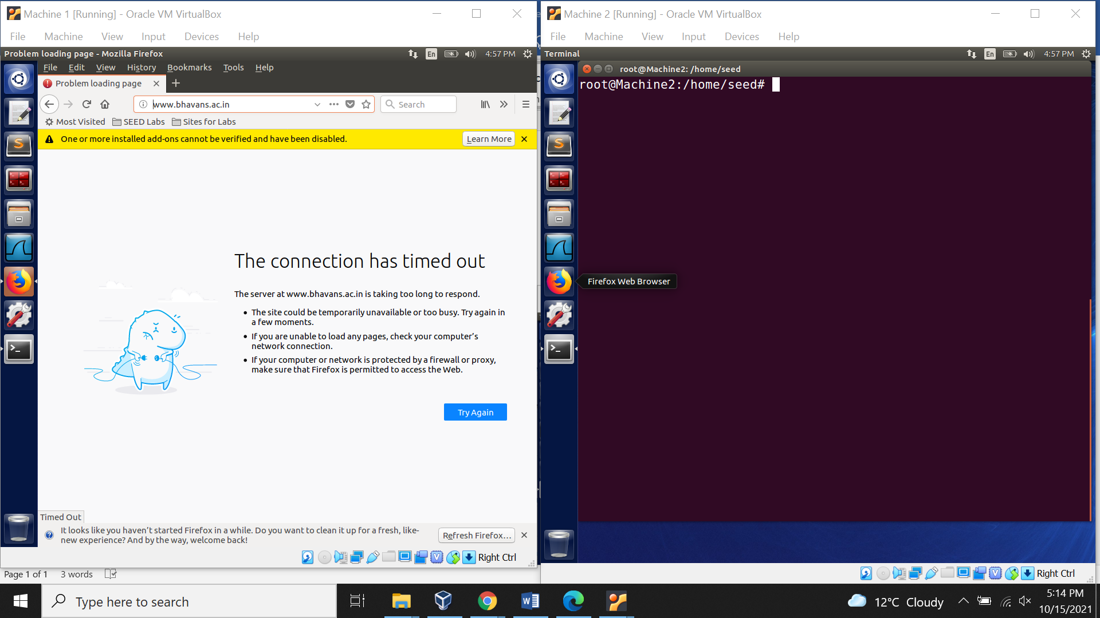

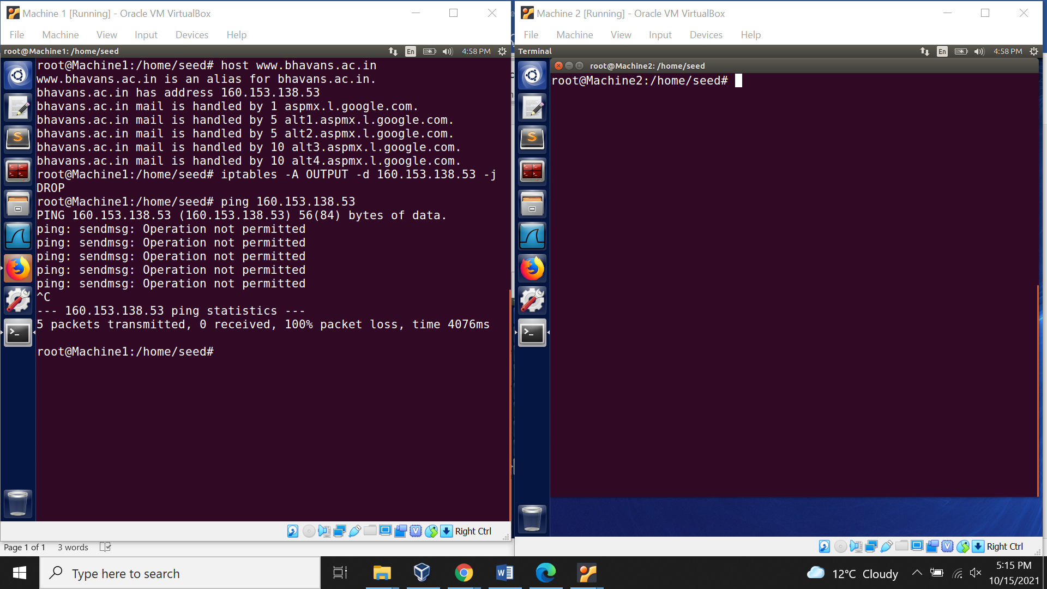

Now, all the iptables rules are removed using command shown.

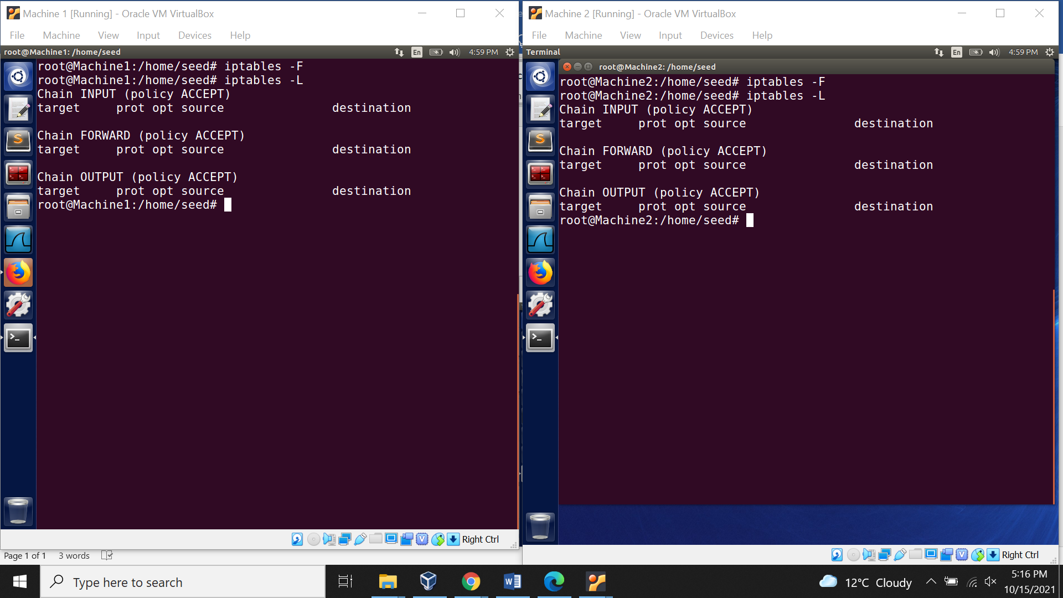

**Task 2**

Implementing a Simple Firewall

Creating directory “lab-task2” in the Desktop folder. Furthermore, code file is created named “zcode.c” in the “lab1-task2” folder.

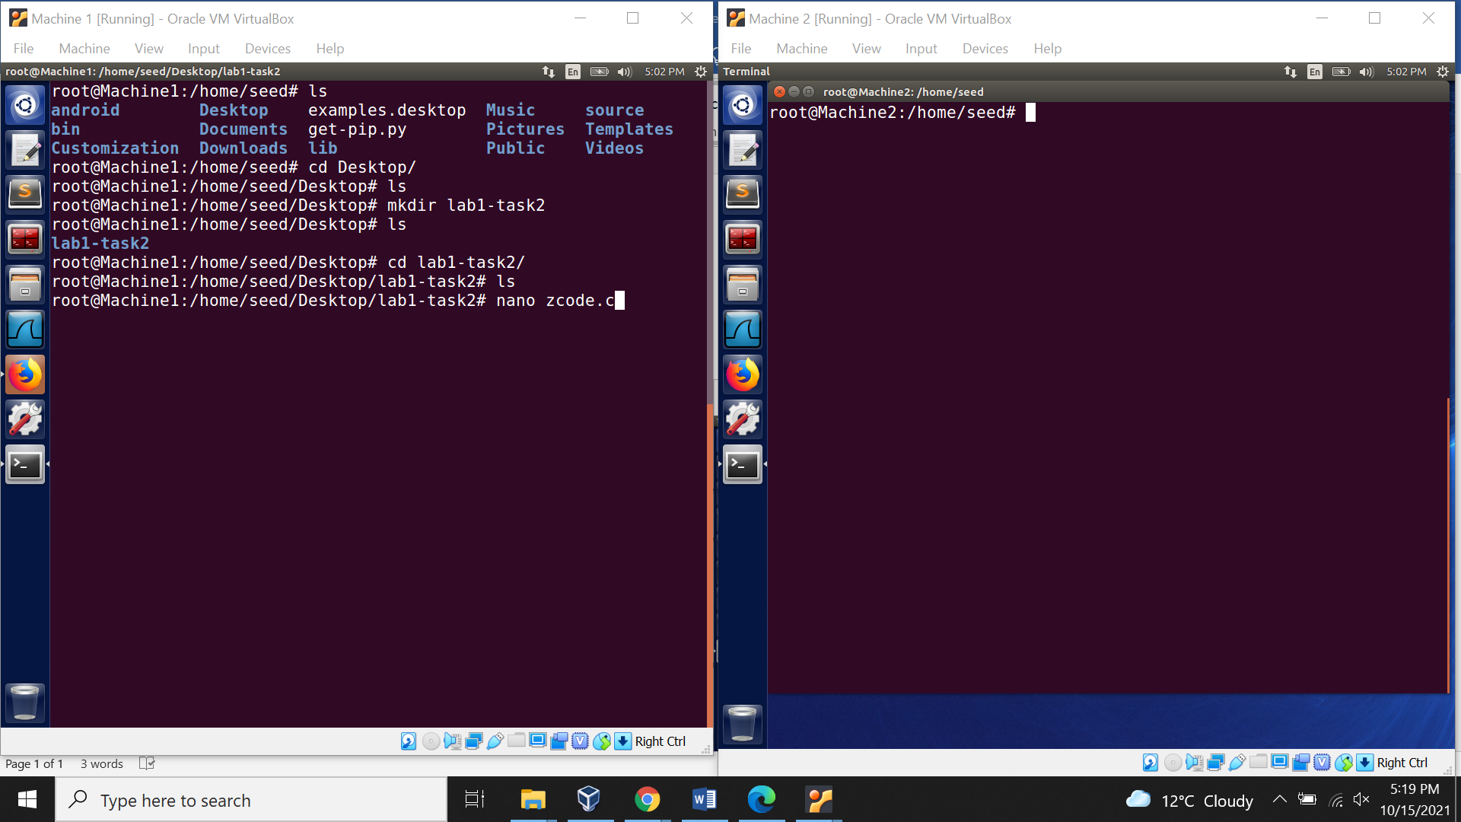

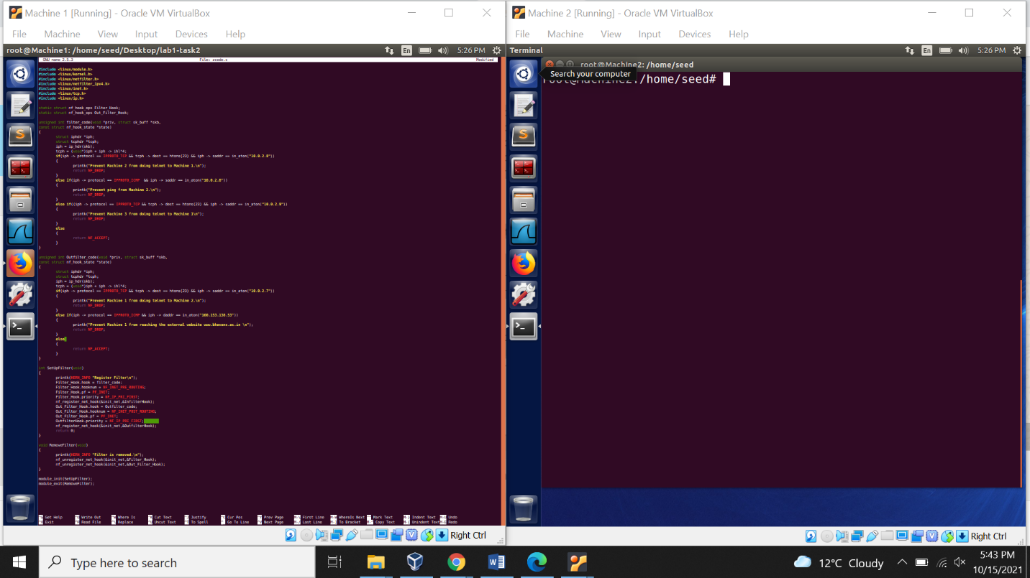

Moreover, ‘Makefile’ is created.

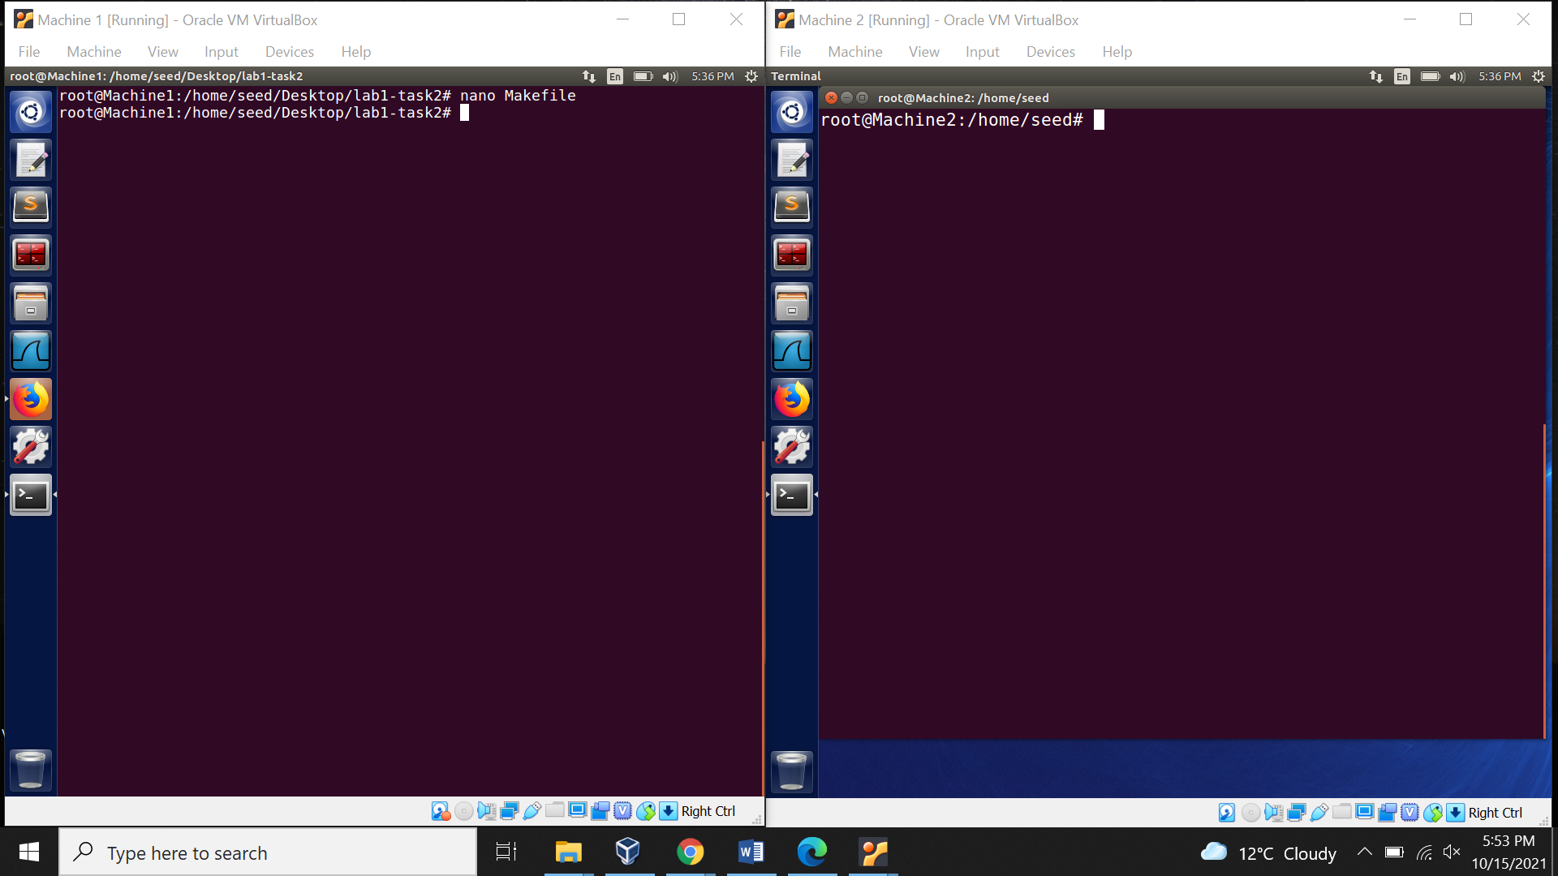

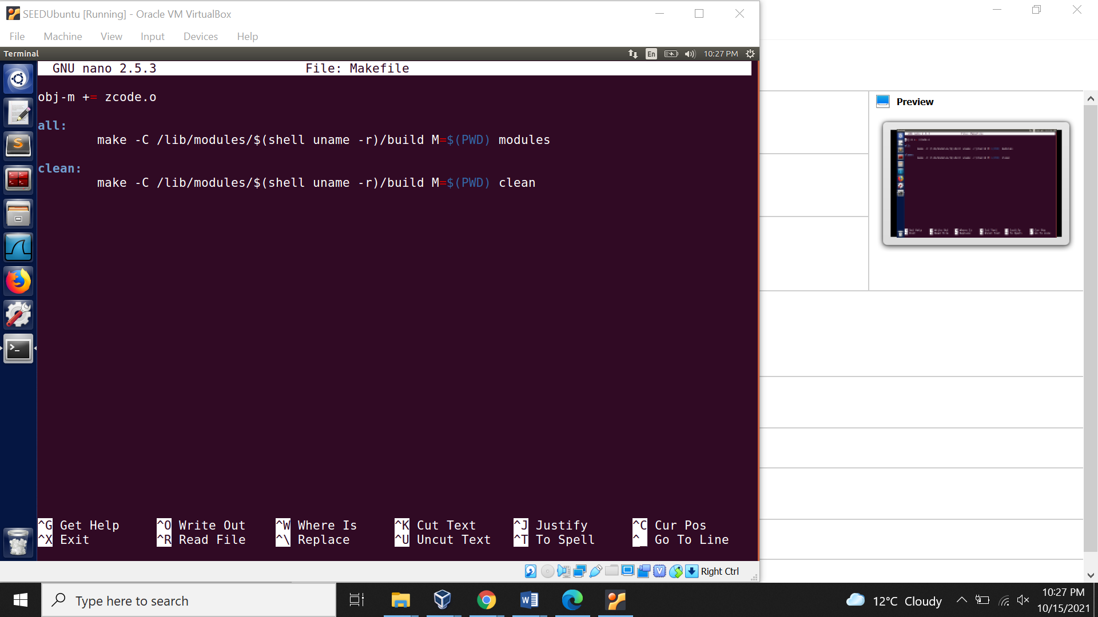

Next, ‘Make’ command is used.

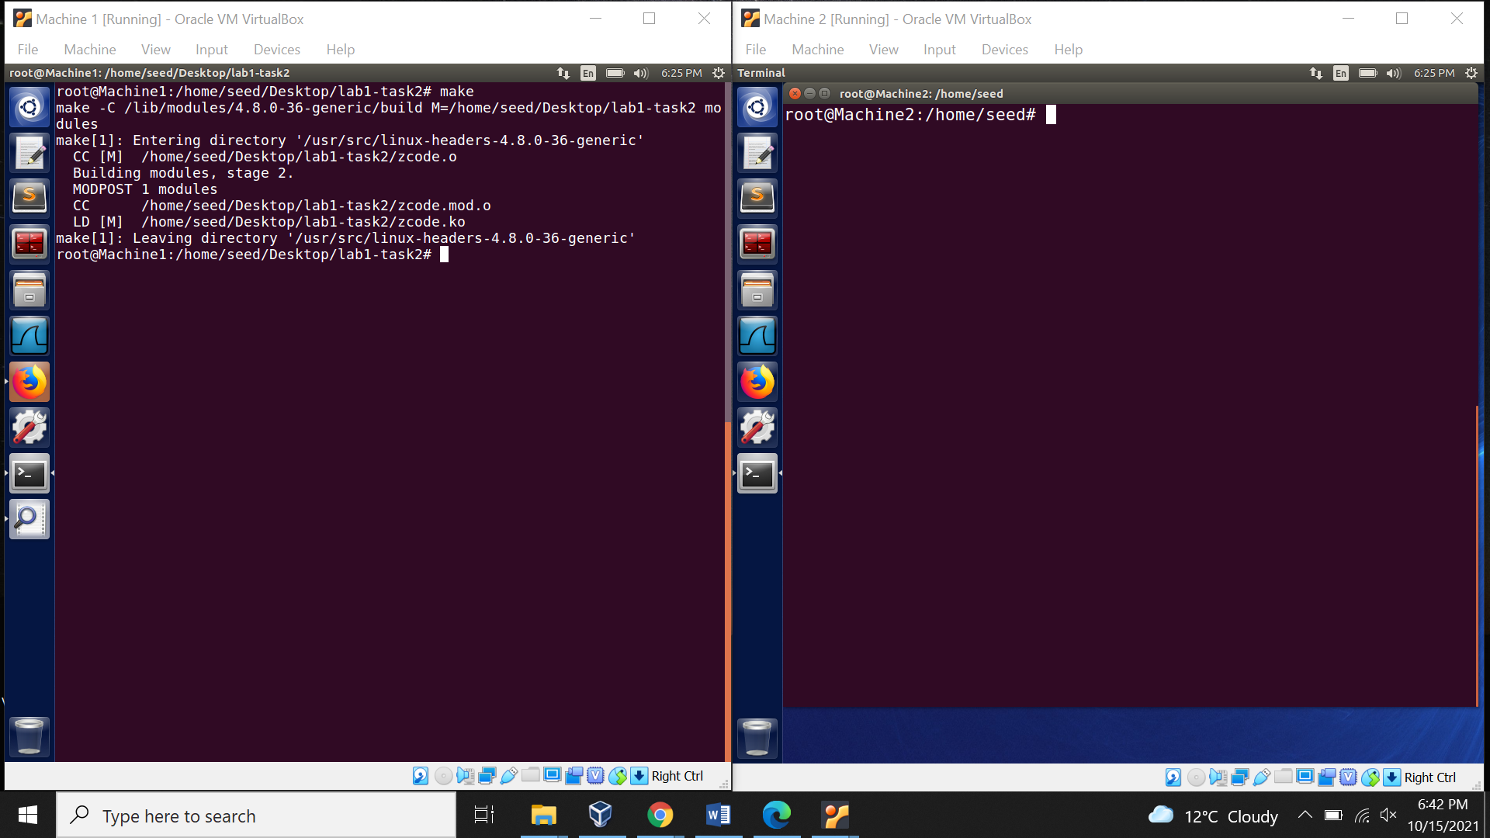

Using the insert mode to using the module.

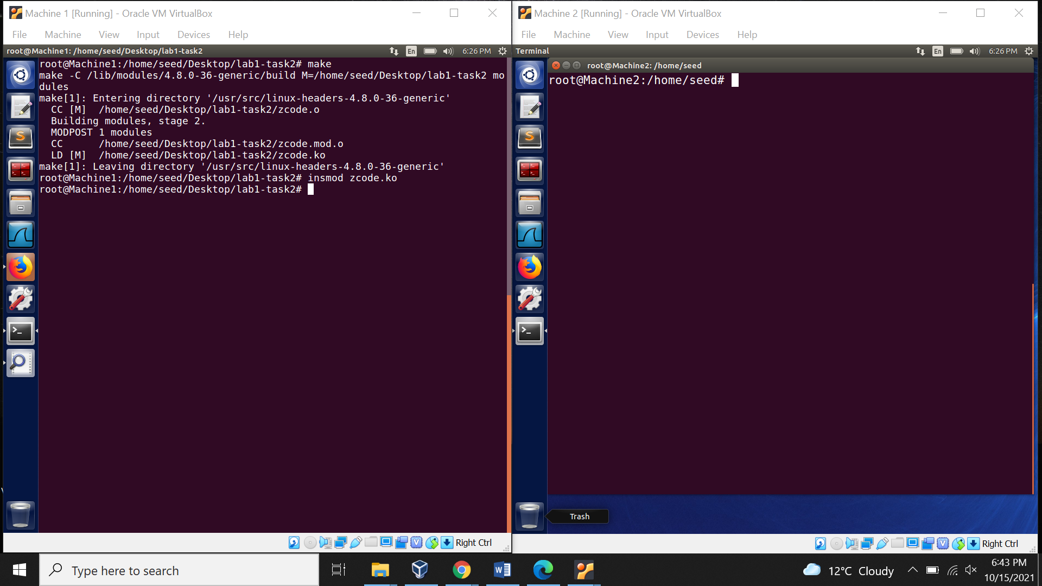

Checking filter is registered using syslogs.

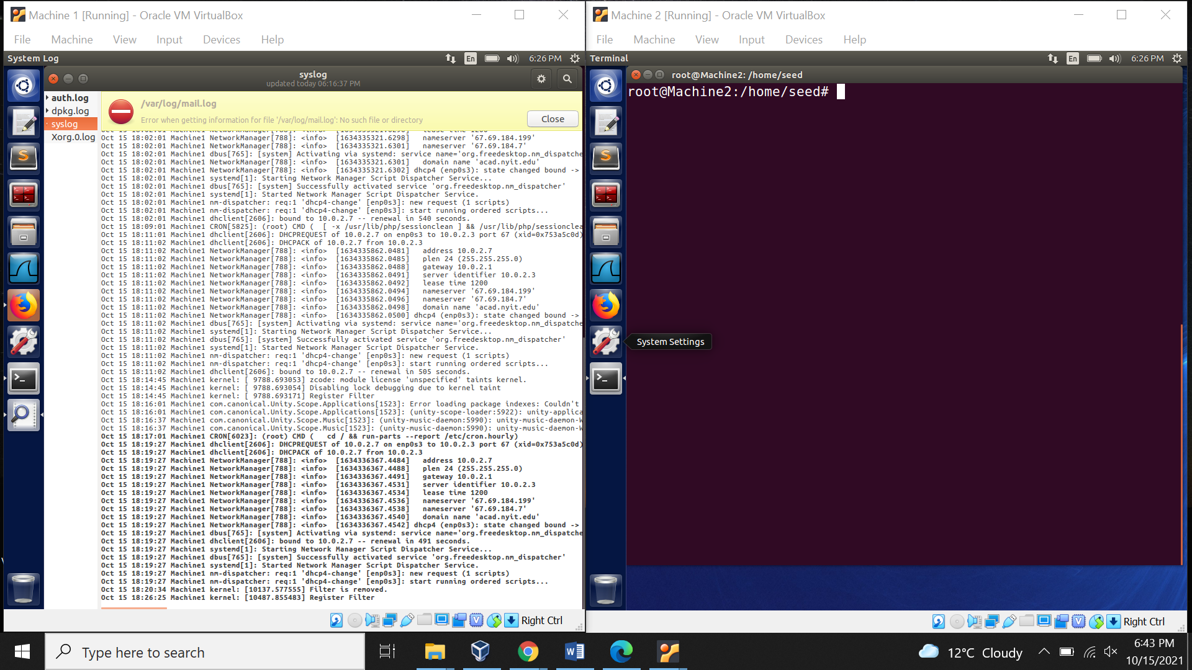

1. Prevent Telnet from Machine 2.

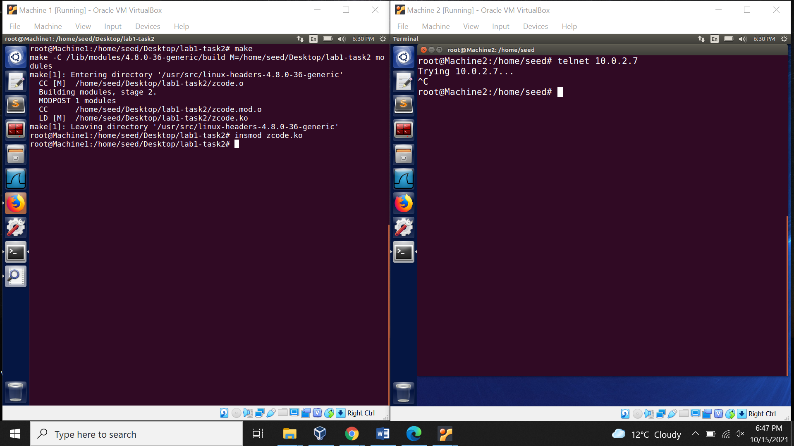

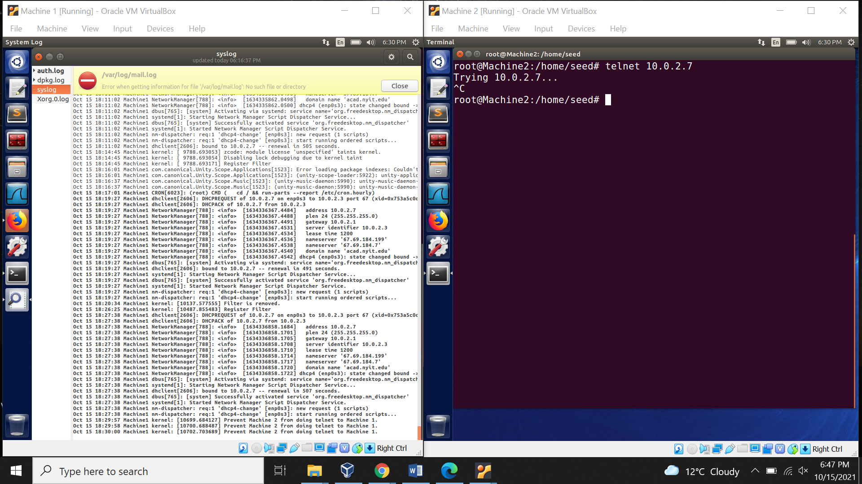

1. Preventing ping from Machine 2.

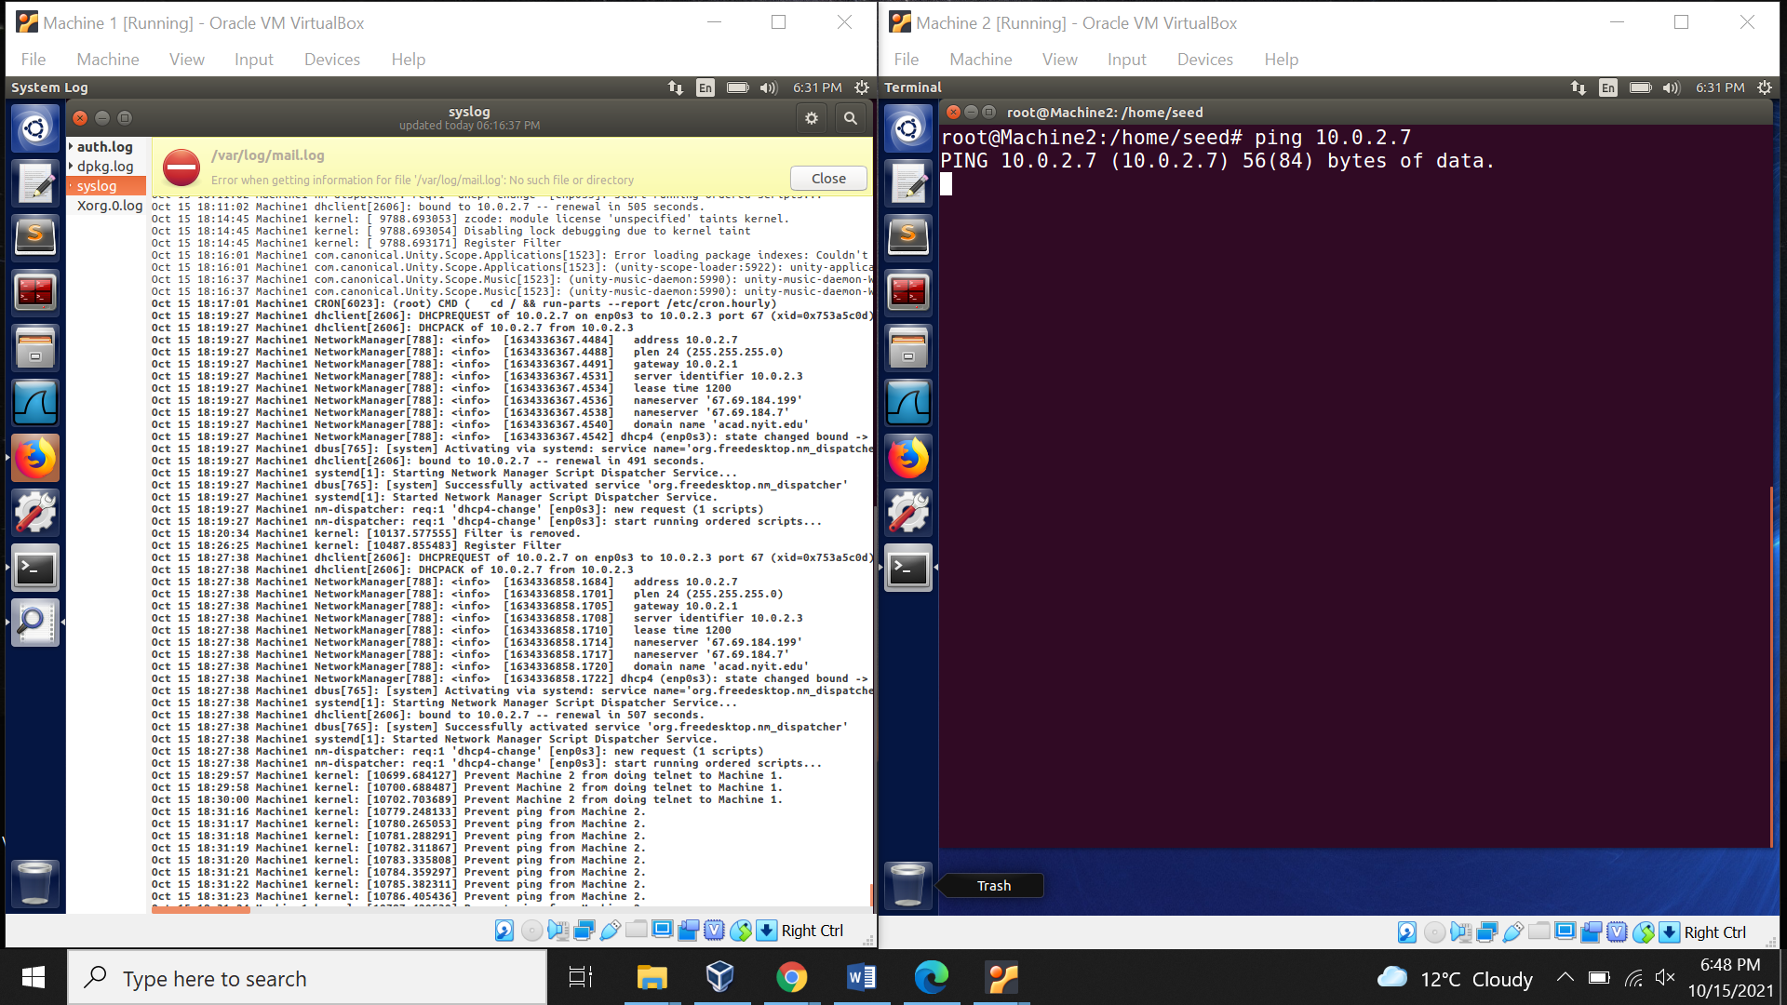

1. Prevent Machine 1 to telnet Machine 2

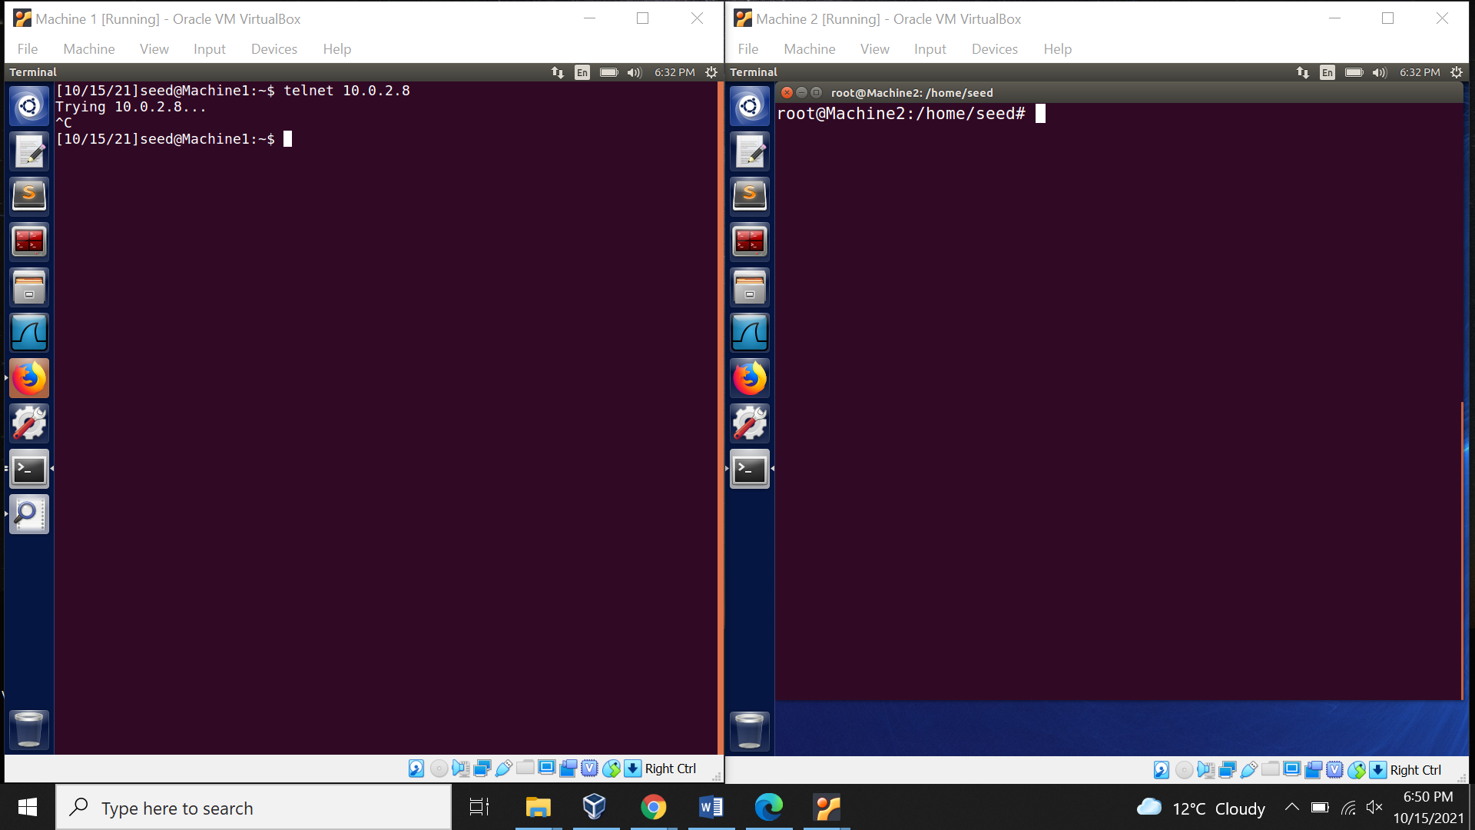

1. Preventing Machine 1 from accessing external website “www.bhavans.ac.in”

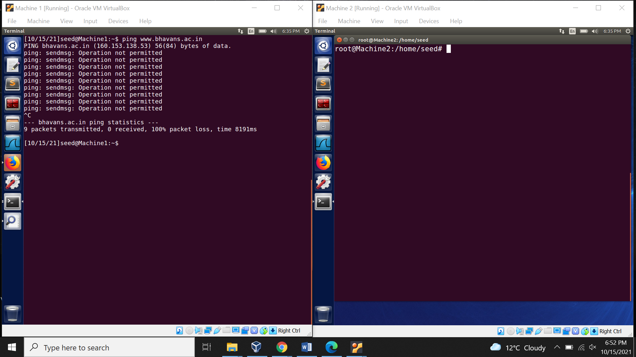

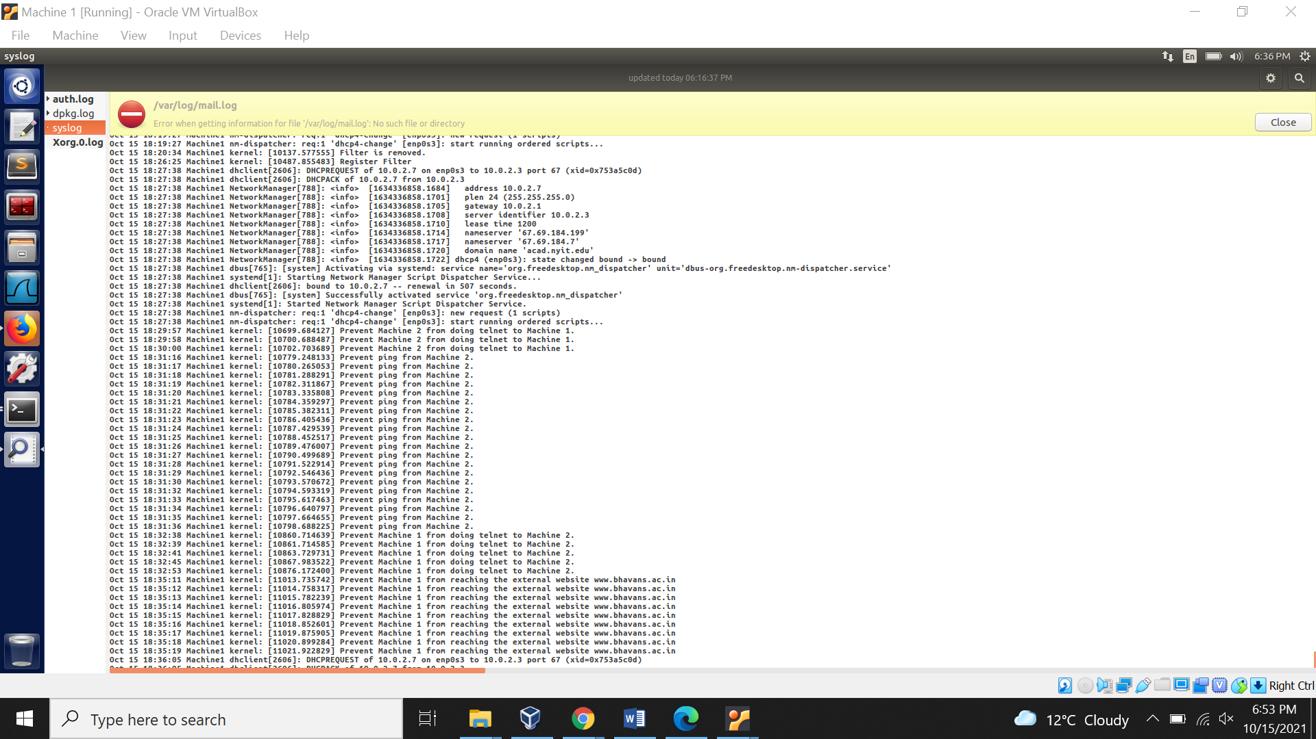

1. Prevent telnet from Machine 3.

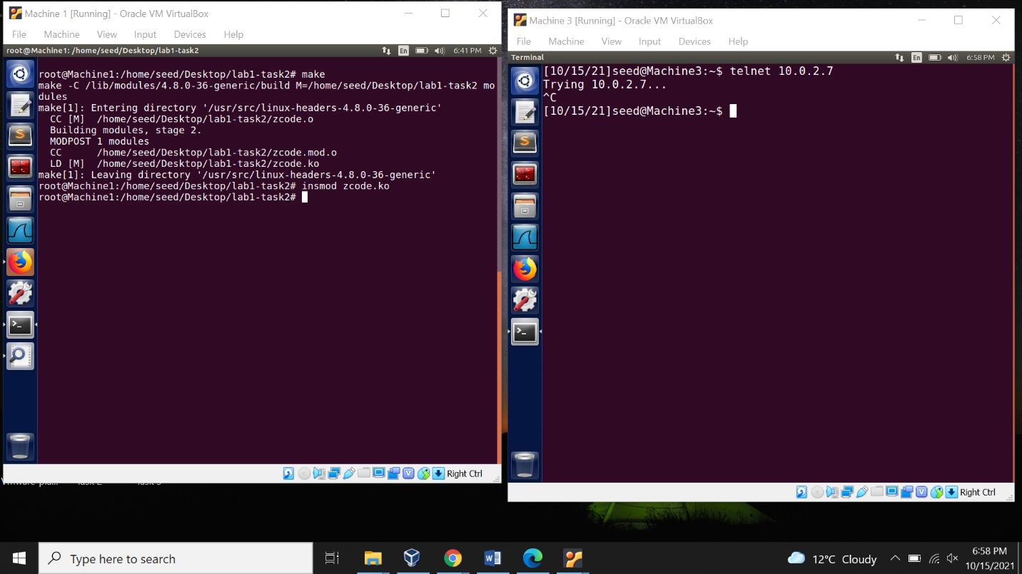

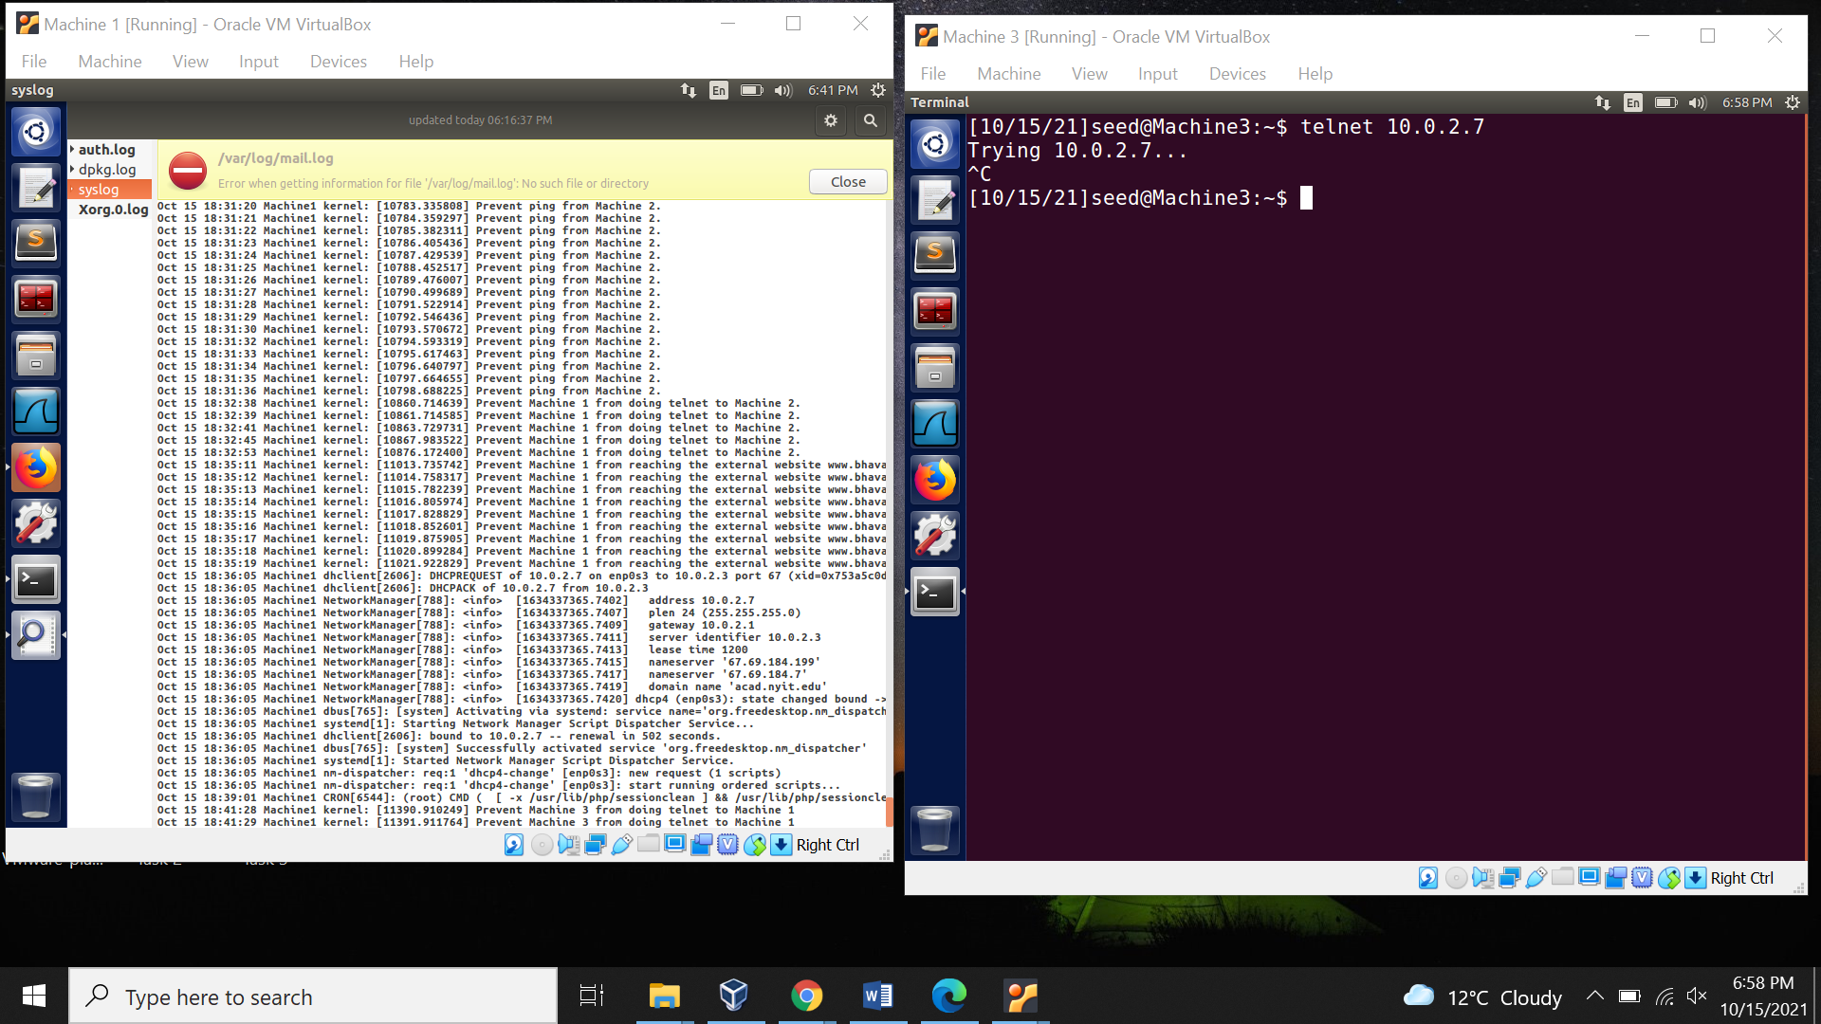

Using rmmod to remove the module.

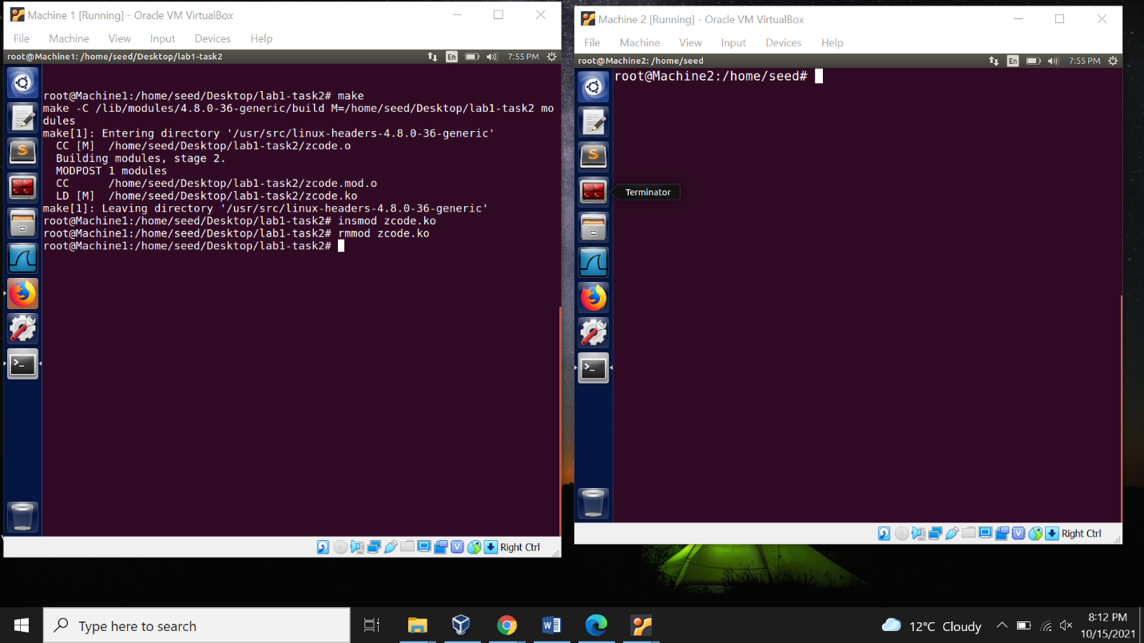

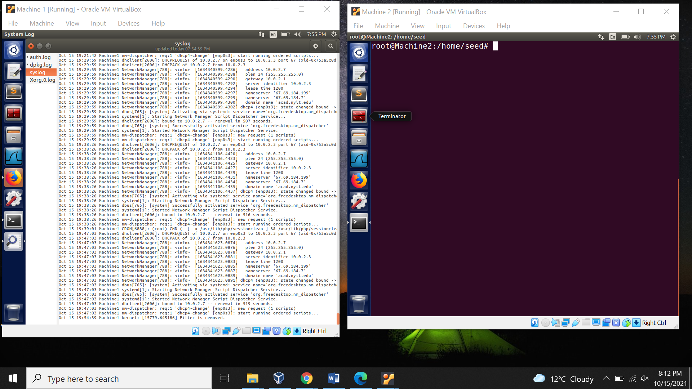

**Task 3: Evading Egress Filtering**

Blocking all the outgoing traffic to external telnet servers.

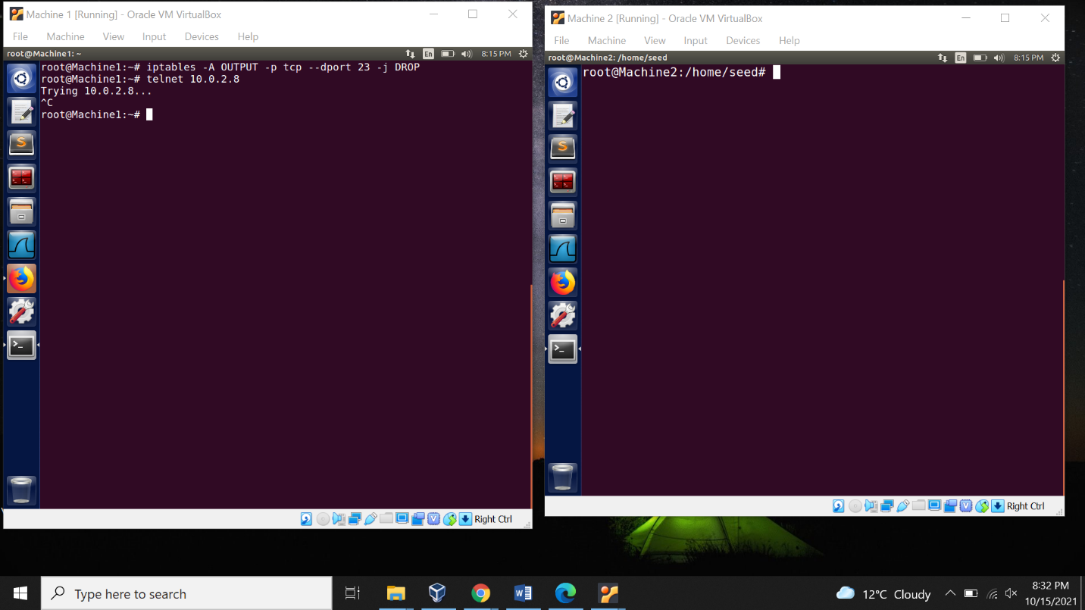

Blocking all the outgoing traffic to [www.facebook.com](http://www.facebook.com)

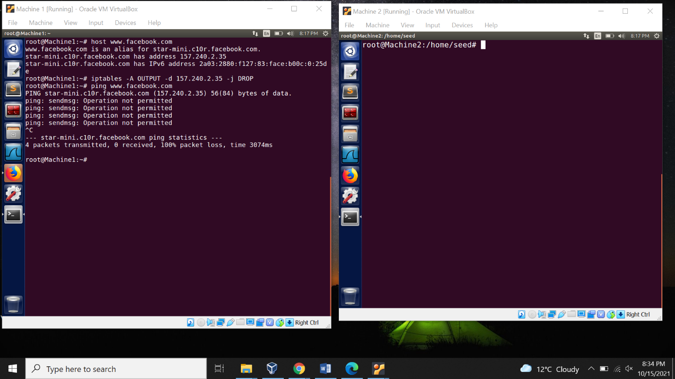

1. Telnet to Machine 2 through the firewall

Connecting to Machine 2

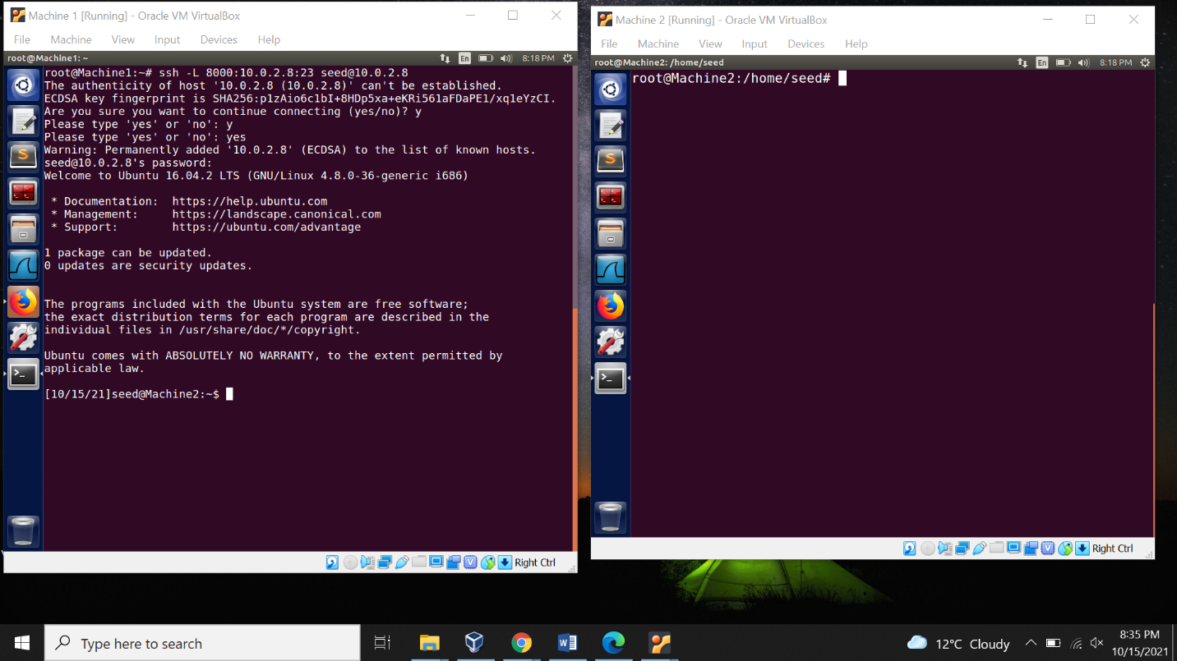

Connecting through Telnet, Machine 2

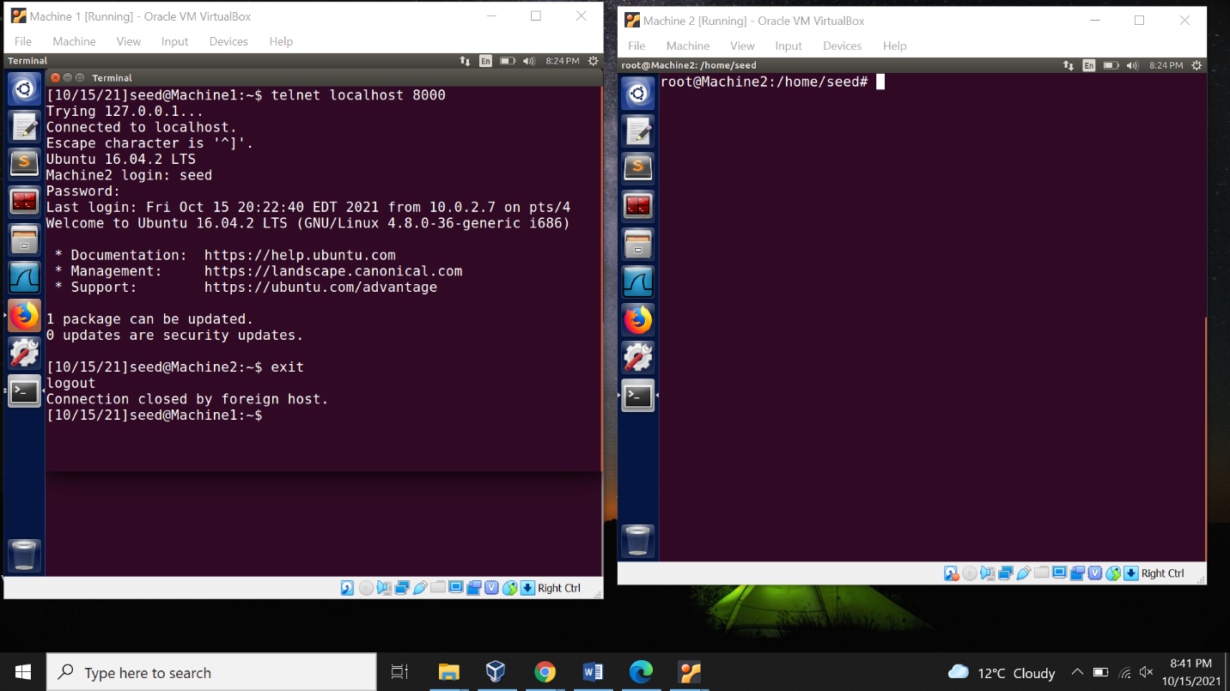

Again, connecting to Machine 2. But wont be able to connect because connection is closed.

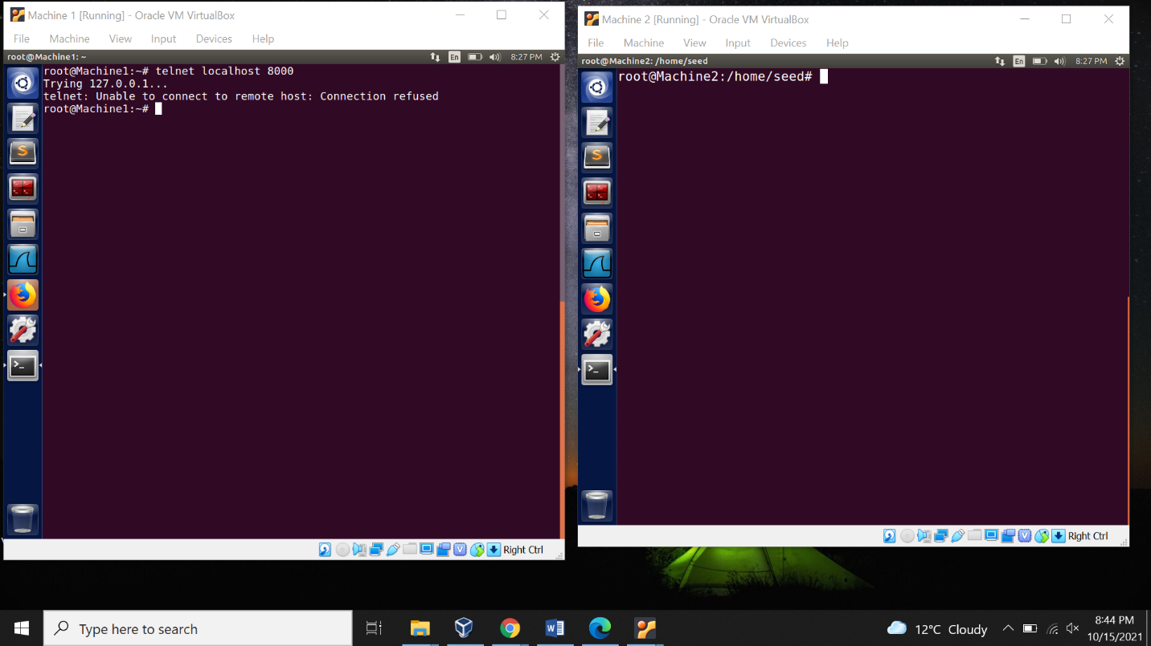

1. Connecting to Facebook using SSH Tunnel

Connecting to Machine 2

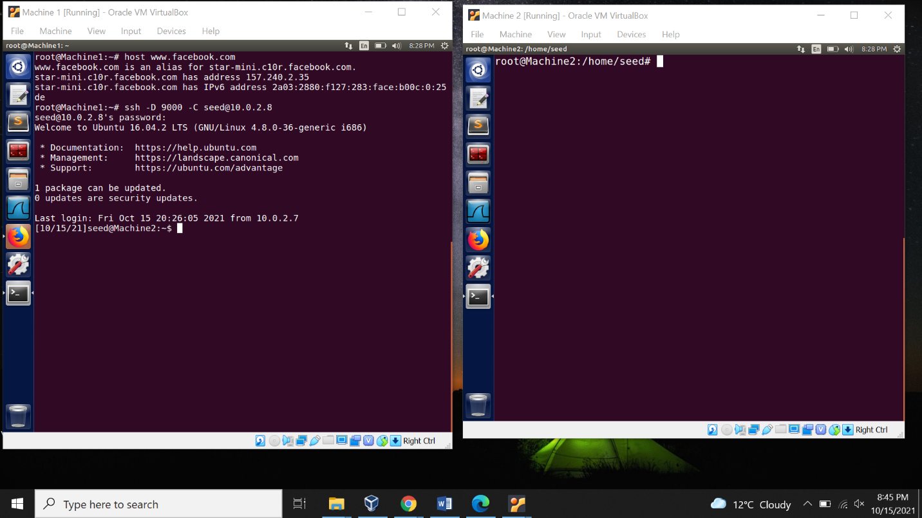

Trying to access Facebook using browser but unsuccessful.

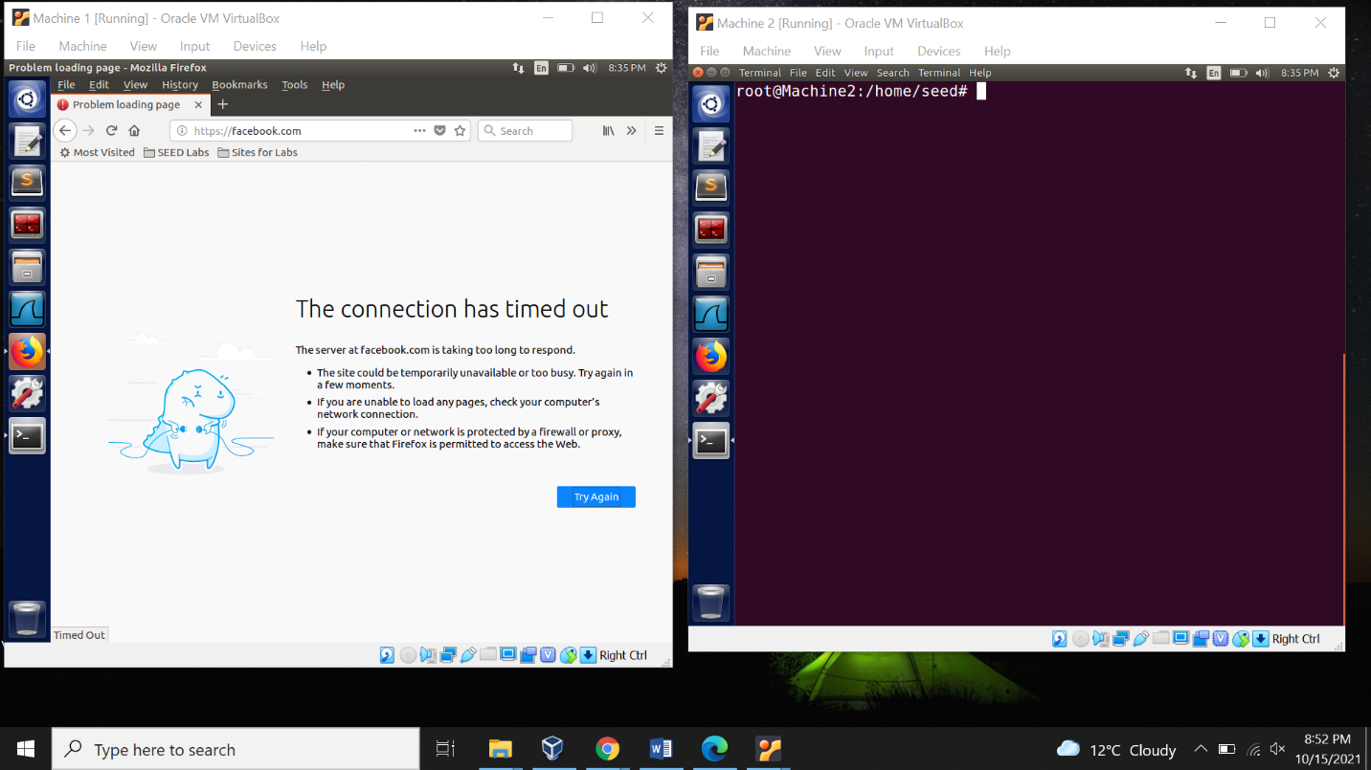

Changing proxy settings

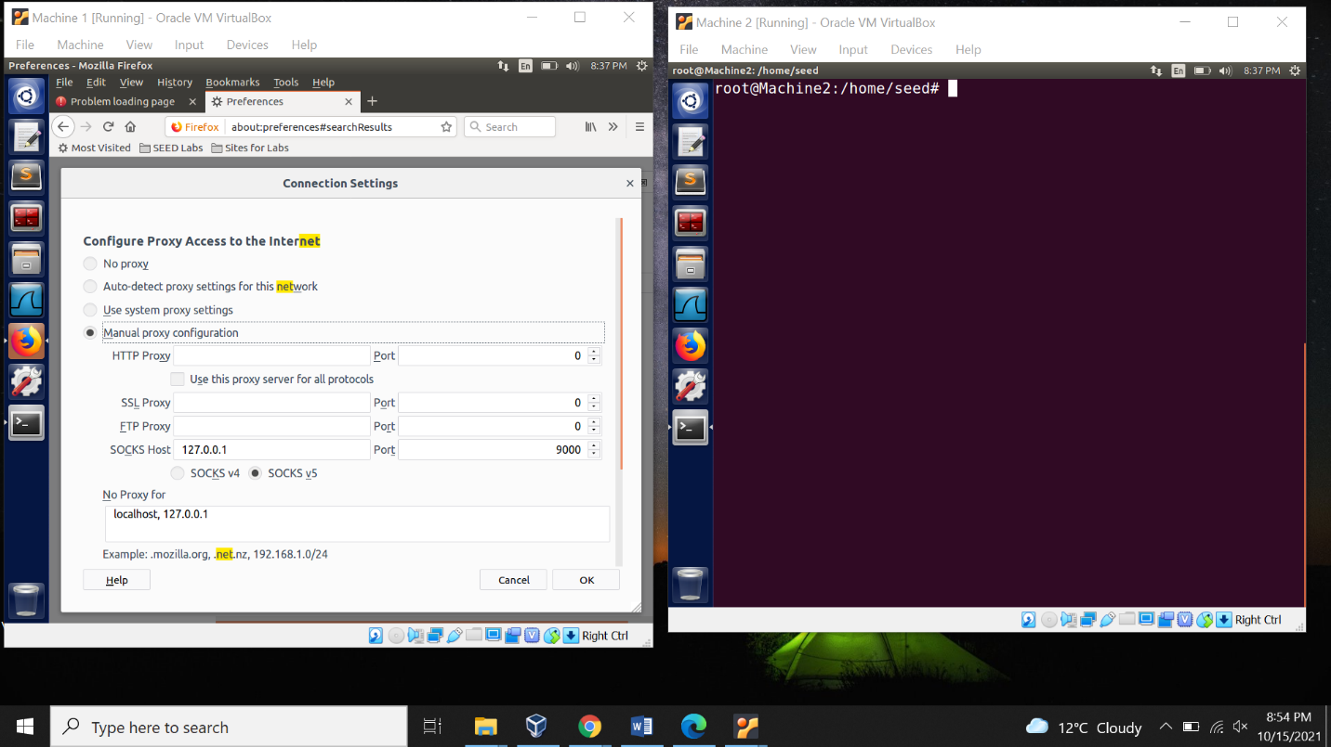

Accessing Facebook successfully.

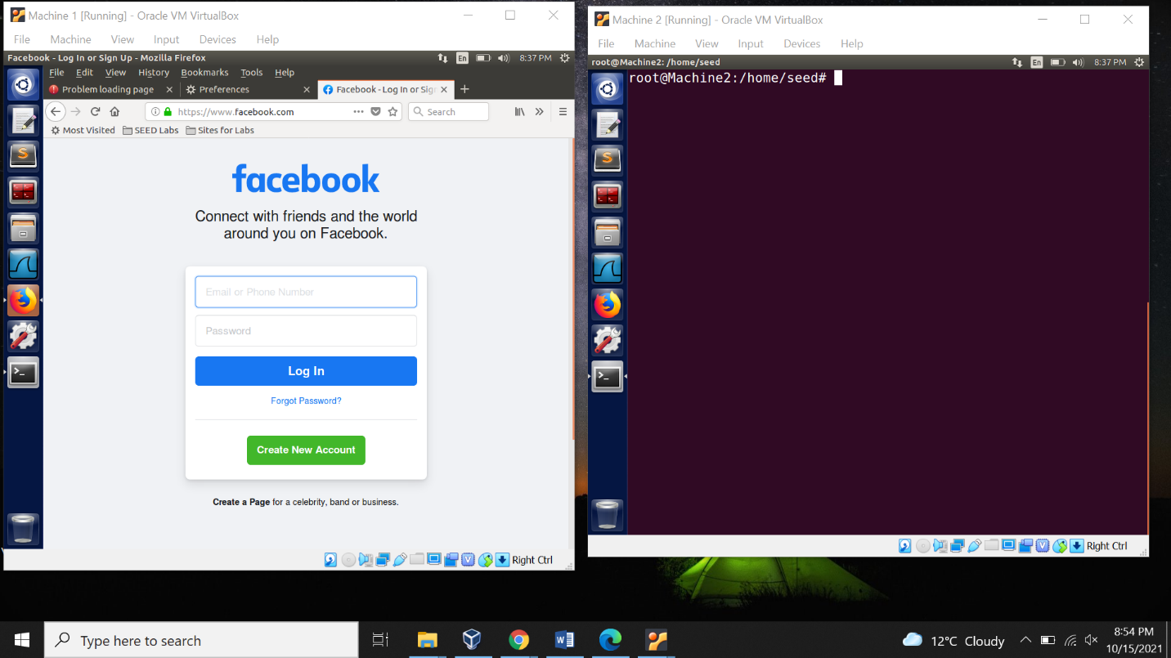

Exit and connection is closed. Now reassessing Facebook but connection is closed.

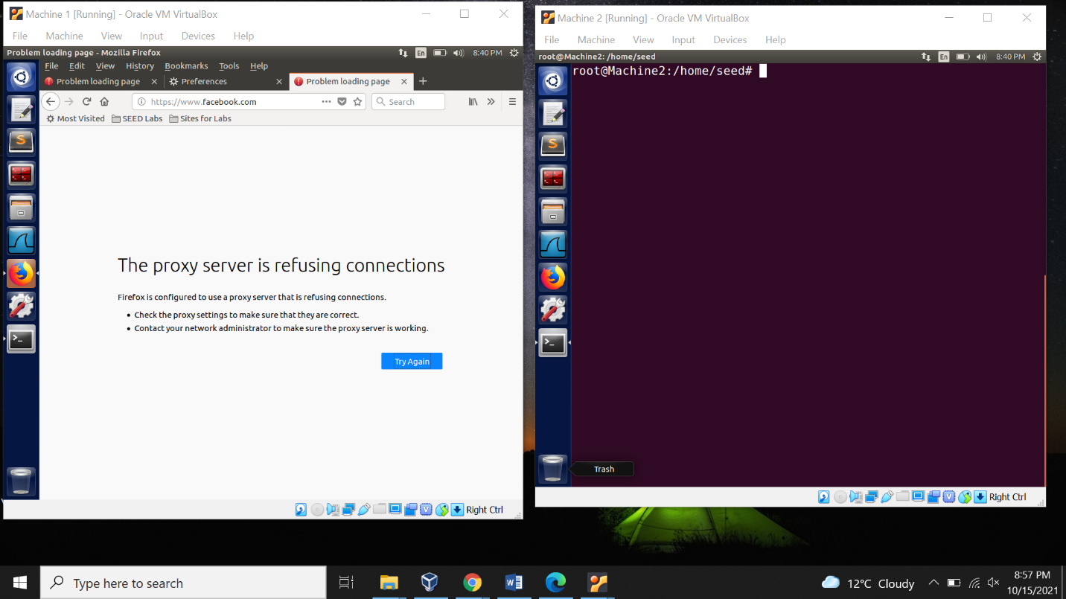

**Task 4: Evading Ingress Filtering**

Blocking the Machine 2 from accessing the port 80 (web server), 22 (SSH server) and 443 (HTTPS)

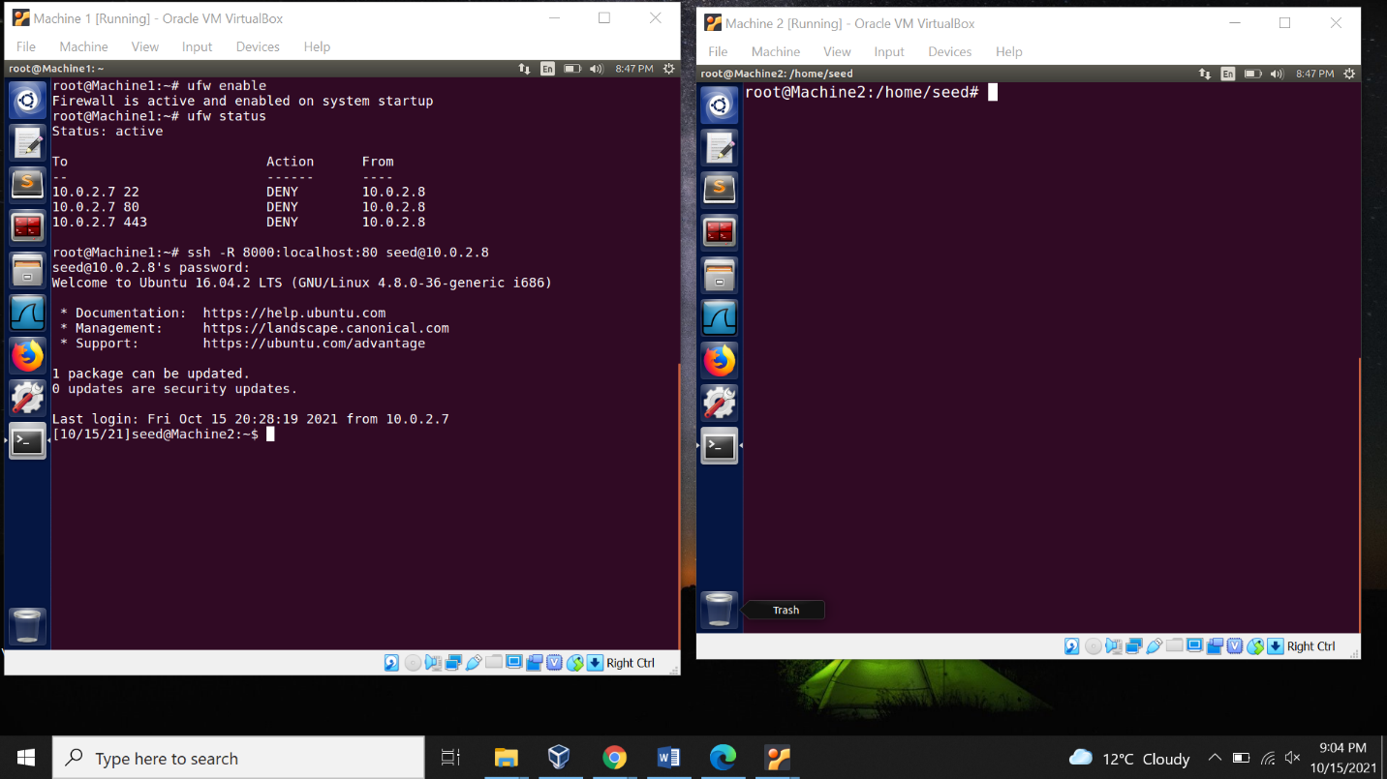

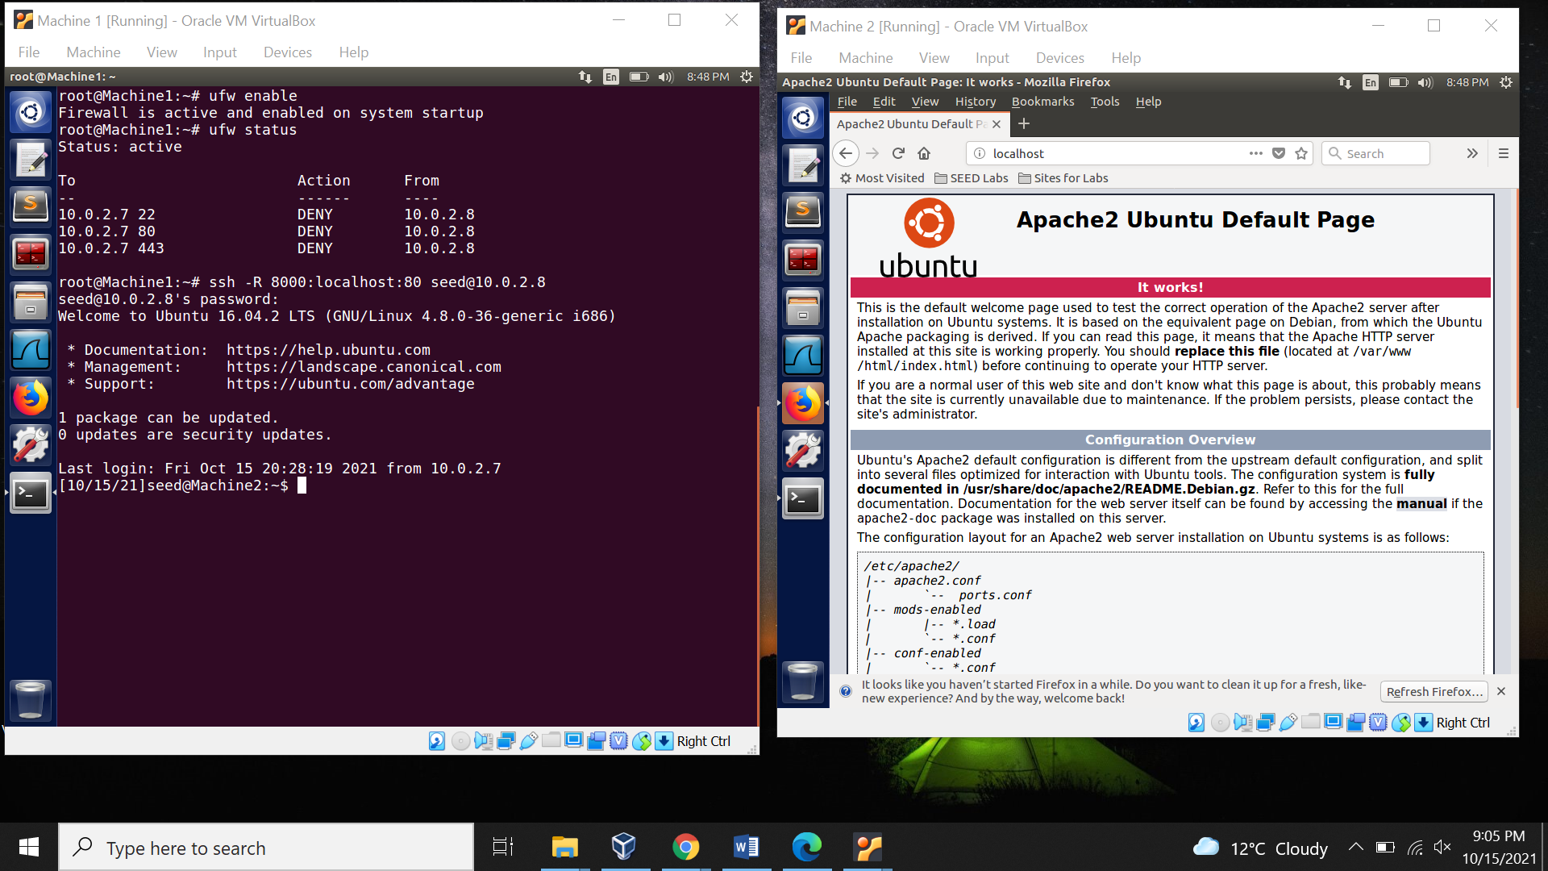

Web server accessed on Machine 1 from Machine 2.

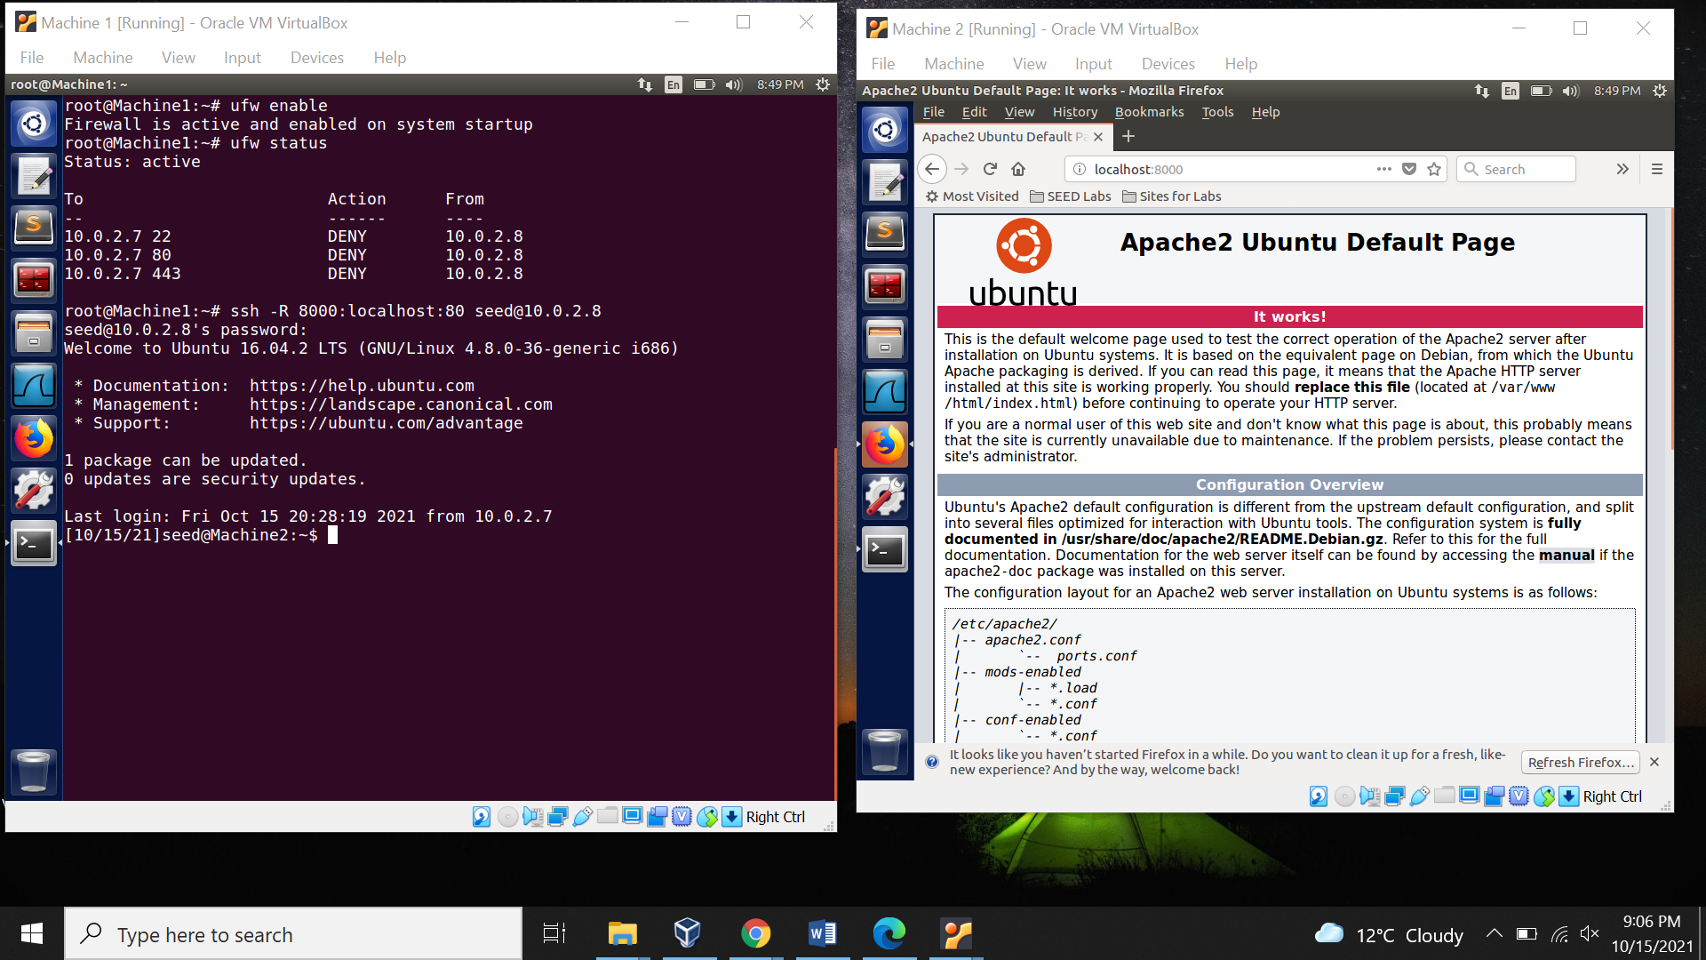

**Appendix**

Codes Used in the Lab 1.

***---------Zcode.c Code----------***

#include <linux/module.h>

#include <linux/kernel.h>

#include <linux/netfilter.h>

#include <linux/netfilter_ipv4.h>

#include <linux/inet.h>

#include <linux/tcp.h>

#include <linux/ip.h>

static struct nf_hook_ops Filter_Hook;

static struct nf_hook_ops Out_Filter_Hook;

unsigned int filter_code(void *priv, struct sk_buff *skb,

const struct nf_hook_state *state)

{

struct iphdr *iph;

struct tcphdr *tcph;

iph = ip_hdr(skb);

tcph = (void*)iph + iph -> ihl*4;

if(iph -> protocol == IPPROTO_TCP && tcph -> dest == htons(23) && iph -> saddr == in_aton("10.0.2.8"))

{

printk("Prevent Machine 2 from doing telnet to Machine 1.\n");

return NF_DROP;

}

else if(iph -> protocol == IPPROTO_ICMP && iph -> saddr == in_aton("10.0.2.8"))

{

printk("Prevent ping from Machine 2.\n");

return NF_DROP;

}

else if(iph -> protocol == IPPROTO_TCP && tcph -> dest == htons(23) && iph -> saddr == in_aton("10.0.2.9"))

{

printk("Prevent Machine 3 from doing telnet to Machine 1\n");

return NF_DROP;

}

else

{

return NF_ACCEPT;

}

}

unsigned int Outfilter_code(void *priv, struct sk_buff *skb,

const struct nf_hook_state *state)

{

struct iphdr *iph;

struct tcphdr *tcph;

iph = ip_hdr(skb);

tcph = (void*)iph + iph -> ihl*4;

if(iph -> protocol == IPPROTO_TCP && tcph -> dest == htons(23) && iph -> saddr == in_aton("10.0.2.7"))

{

printk("Prevent Machine 1 from doing telnet to Machine 2.\n");

return NF_DROP;

}

else if(iph -> protocol == IPPROTO_ICMP && iph -> daddr == in_aton("160.153.138.53"))

{

printk("Prevent Machine 1 from reaching the external website www.bhavans.ac.in \n");

return NF_DROP;

}

else

{

return NF_ACCEPT;

}

}

int SetUpFilter(void)

{

printk(KERN_INFO "Register Filter\n");

Filter_Hook.hook = filter_code;

Filter_Hook.hooknum = NF_INET_PRE_ROUTING;

Filter_Hook.pf = PF_INET;

Filter_Hook.priority = NF_IP_PRI_FIRST;

nf_register_net_hook(&init_net,&Filter_Hook);

Out_Filter_Hook.hook = Outfilter_code;

Out_Filter_Hook.hooknum = NF_INET_POST_ROUTING;

Out_Filter_Hook.pf = PF_INET;

Out_Filter_Hook.priority = NF_IP_PRI_FIRST;

nf_register_net_hook(&init_net,&Out_Filter_Hook);

return 0;

}

void RemoveFilter(void)

{

printk(KERN_INFO "Filter is removed.\n");

nf_unregister_net_hook(&init_net,&Filter_Hook);

nf_unregister_net_hook(&init_net,&Out_Filter_Hook);

}

module_init(SetUpFilter);

module_exit(RemoveFilter);

**---------Makefile Code---------**

obj-m += zcode.o

all:

make -C /lib/modules/$(shell uname -r)/build M=$(PWD) modules

clean:

make -C /lib/modules/$(shell uname -r)/build M=$(PWD) clean